**Visvesvaraya Technological University**

### Belgaum-590014



**A DBMS Mini-Project Report**

**On**

***“Zoo Database Management System”***

*A Miniproject report submitted in partial fulfillment of the requirements for the 5th semester of* ***Bachelor of Engineering in Computer Science and Engineering***

*of Visvesvaraya Technological University, Belgaum*

Submitted by:

**SHREESHA SHETTY 1RN15CS101**

**SUNIDHI HEGDE 1RN15CS110**

Under the Guidance of:

**Prof. Karanam Sunil Kumar Prof. Manjula L**

**Asst Professor Asst Professor**

**Dept. of CSE Dept. of CSE**



**Department of Computer Science and Engineering**

**RNS Institute of Technology**

**Channasandra, Uttarahalli-Kengeri Main Road, Bangalore-560 098**

**2017-2018**

**RNS Institute of Technology**

Channasandra, Uttarahalli-Kengeri Main Road,

Bangalore-560 061

**Department of Computer Science & Engineering**



**CERTIFICATE**

Certified that the mini project work entitled **“Zoo Database Management System”** has been successfully carried out by **Sunidhi Hegde** bearing USN **1RN15CS110** and **Shreesha Shetty** bearing USN **1RN15CS101,** bonafide students of **RNS Institute of Technology** in partial fulfillment of the requirements for the **5th semester** of **Bachelor of Engineering** in **Computer Science and Engineering** of **Visvesvaraya Technological University**, Belgaum, during academic year 2017-2018. It is certified that all corrections/suggestions indicated for Internal Assessment have been incorporated in the report deposited in the departmental library. The project report has been approved as it satisfies the laboratory requirements of 5th semester BE, CSE.

**Prof. Karanam Sunil Kumar Prof.Manjula L Dr. G T Raju**

**Asst Prof. Asst Prof. Prof.andHead**

**Dept. of CSE Dept. of CSE Dept of CSE**

**External Viva:**

**Name of the Examiners Signature with Date**

**1.**

**2.**

**ACKNOWLEDGEMENT**

Any achievement, be it scholastic or otherwise does not depend solely on the individual efforts but on the guidance, encouragement and cooperation of intellectuals, elders and friends. A number of personalities, in their own capacities have helped me in carrying out this project work. We would like to take this opportunity to thank them all.

We would like to thank**Dr. H N Shivashankar**, Director, RNSIT, Bangalore, for his moral support towards completing my project.

We are grateful to**Dr. M K Venkatesha,** Principal, RNSIT,Bangalore, for his support towards completing my project.

We would like to thank **Dr. G T Raju**, Dean of Engg.,Prof &Head , Department of Computer Science & Engineering, RNSIT, Bangalore, for his valuable suggestions and expert advice.

We deeply express my sincere gratitude to my guide **Prof.Sunil Kumar** and **Prof.Manjula L**, Asst Prof, Department of CSE, RNSIT, Bangalore, for their able guidance, regular source of encouragement and assistance throughout this project.

We would like to thank all the teaching and non-teaching staff of Department of Computer Science & Engineering RNSIT, Bangalore for their constant support and encouragement.

Date: 22-11-2017 **Students’ names**

Place: Bangalore Shreesha Shetty

Sunidhi Hegde

**ABSTRACT**

Technology has become imperative in today’s day to day functioning of every possible sector in the society. One of the key contributions of technology has been optimization of human effort. In an attempt to utilize and develop a systematic information storage and retrieval system for one such domain, the idea of Zoo Database Management System originated. Many national parks and zoos lack the sophistication required for the current boom in tourism. The information concerning the employees and the animals is usually stored in files and records which often leads to tedious work in terms of storage , access and updation . This project is an endeavor to simplify the maintenance of a zoo and to also make the access of information secure, quick, reliable and hassle-free.

**CONTENTS**

|  |  |
| --- | --- |
|  |  |
| |  |  | | --- | --- | | **Chapter** | **Page No** | | 1.Introduction to Database Management System | 1-3 | | 1.1 Introduction | 1 | | 1.2 History of DBMS | 2 | | 1.3 Characteristics of Database Approach | 3 | | 1.4 Applications of DBMS | 3 | | 2. Schema and ER Diagram | 4-5 | | 2.1 ER Diagram | 4 | | 2.2 Schema Diagram | 5 | | 3. Resource Requirements | 6 | | 3.1 Hardware Requirements | 6 | | 3.2 Software Requirements | 6 | | 4. Description of Tools and Technologies  4.1 HTML  4.2 CSS  4.3 PHP  4.4 MySQL | 7-12  7  8  8  10 | | 5. PHP Database Connectivity | 13-15 | | 6. Implementation | 16-109 | | 7. Snapshots | 109-115 | | 8. Conclusion and Future enhancement | 116 | | 9.Bibliography | 117 | |  |  | |  |  | |  |
|  |  |
|  |  |

**CHAPTER 1**

**INTRODUCTION TO DATABASE MANAGEMENT SYSTEM**

1.1Introduction

Databases and database technology have a major impact on the growing use of computers. It is fair to say that databases play a critical role in almost all areas where computers are used, including business, electronic commerce, engineering, medicine, genetics, law, education, and library science. The word database is so commonly used that we must begin by defining what a database is. Our initial definition is quite general. A database is a collection of related data.1 By data, we mean known facts that can be recorded and that have implicit meaning. For example, consider the names, telephone numbers, and addresses of the people you know. You may have recorded this data in an indexed address book or you may have stored it on a hard drive, using a personal computer and software such as Microsoft Access or Excel. This collection of related data with an implicit meaning is a database. The preceding definition of database is quite general; for example, we may consider the collection of words that make up this page of text to be related data and hence to constitute a database. However, the common use of the term database is usually more restricted.

A database has the following implicit properties:

* A database represents some aspect of the real world, sometimes called the miniworld or the universe of discourse (UoD). Changes to the miniworld are reflected in the database.
* A database is a logically coherent collection of data with some inherent meaning. A random assortment of data cannot correctly be referred to as a database.
* A database is designed, built, and populated with data for a specific purpose. It has an intended group of users and some preconceived applications in which these users are interested.

A database management system (DBMS) is a collection of programs that enables users to create and maintain a database. The DBMS is a general-purpose software system that facilitates the processes of defining, constructing, manipulating, and sharing databases among various users and applications. Defining a database involves specifying the data types, structures, and constraints of the data to be stored in the database. The database definition or descriptive information is also stored by the DBMS in the form of a database catalog or dictionary; it is called meta-data. Constructing the database is the process of storing the data on some storage medium that is controlled by the DBMS. Manipulating a database includes functions such as querying the database to retrieve specific data, updating the database to reflect changes in the miniworld, and generating reports from the data. Sharing a database allows multiple users and programs to access the database simultaneously.

**1.2 HISTORY OF DBMS**

In 1959, the [TX-2](http://en.wikipedia.org/wiki/TX-2) computer was developed at [MIT's Lincoln Laboratory](http://en.wikipedia.org/wiki/Lincoln_Laboratory). The TX-2 integrated a number of new man-machine interfaces. A light pen could be used to draw sketches on the computer using [Ivan Sutherland](http://en.wikipedia.org/wiki/Ivan_Sutherland)'s revolutionary [Sketchpad software](http://en.wikipedia.org/wiki/Sketchpad).[4] Using a light pen, Sketchpad allowed one to draw simple shapes on the computer screen, save them and even recall them later. The light pen itself had a small photoelectric cell in its tip. This cell emitted an electronic pulse whenever it was placed in front of a computer screen and the screen's electron gun fired directly at it. By simply timing the electronic pulse with the current location of the electron gun, it was easy to pinpoint exactly where the pen was on the screen at any given moment. Once that was determined, the computer could then draw a cursor at that location. Also in 1961 another student at MIT, [Steve Russell](http://en.wikipedia.org/wiki/Steve_Russell), created the first video game, E. E. Zajac, a scientist at [Bell Telephone Laboratory](http://en.wikipedia.org/wiki/Bell_Labs) (BTL), created a film called "Simulation of a two-giro gravity attitude control system" in 1963.

During 1970s, the first major advance in 3D computer graphics was created at UU by these early pioneers, the hidden-surface algorithm. In order to draw a representation of a 3D object on the screen, the computer must determine which surfaces are "behind" the object from the viewer's perspective, and thus should be "hidden" when the computer creates (or renders) the image.

In the 1980s, artists and graphic designers began to see the personal computer, particularly the [Commodore Amiga](http://en.wikipedia.org/wiki/Commodore_Amiga) and [Macintosh](http://en.wikipedia.org/wiki/Apple_Macintosh), as a serious design tool, one that could save time and draw more accurately than other methods. In the late 1980s, [SGI](http://en.wikipedia.org/wiki/Silicon_Graphics) computers were used to create some of the first fully computer-generated [short films](http://en.wikipedia.org/wiki/Short_film) at [Pixar](http://en.wikipedia.org/wiki/Pixar). The Macintosh remains a highly popular tool for computer graphics among graphic design studios and businesses. Modern computers, dating from the 1980s often use [graphical user interfaces](http://en.wikipedia.org/wiki/Graphical_user_interfaces)(GUI) to present data and information with symbols, icons and pictures, rather than text. Graphics are one of the five key elements of [multimedia](http://en.wikipedia.org/wiki/Multimedia) technology.

[3D graphics](http://en.wikipedia.org/wiki/3D_graphics) became more popular in the 1990s in [gaming](http://en.wikipedia.org/wiki/Video_game), [multimedia](http://en.wikipedia.org/wiki/Multimedia) and [animation](http://en.wikipedia.org/wiki/Animation). In 1996, [Quake](http://en.wikipedia.org/wiki/Quake), one of the first fully 3D [games](http://en.wikipedia.org/wiki/Game), was released. In 1995, [Toy Story](http://en.wikipedia.org/wiki/Toy_Story), the first full-length computer-generated animation film, was released in cinemas worldwide. Since then, computer graphics have only become more detailed and realistic, due to more powerful graphics hardware and 3D modelling software.

* 1. **APPLICATIONS OF DBMS**

Applications where we use Database Management Systems are:

* **Telecom**: There is a database to keeps track of the information regarding calls made, network usage, customer details etc. Without the database systems it is hard to maintain that huge amount of data that keeps updating every millisecond.
* **Industry**: Where it is a manufacturing unit, warehouse or distribution centre, each one needs a database to keep the records of ins and outs. For example distribution centre should keep a track of the product units that supplied into the centre as well as the products that got delivered out from the distribution centre on each day; this is where DBMS comes into picture.
* **Banking System**: For storing customer info, tracking day to day credit and debit transactions, generating bank statements etc. All this work has been done with the help of Database management systems.
* **Education sector**: Database systems are frequently used in schools and colleges to store and retrieve the data regarding student details, staff details, course details, exam details, payroll data, attendance details, fees details etc. There is a hell lot amount of inter-related data that needs to be stored and retrieved in an efficient manner.
* **Online shopping**: You must be aware of the online shopping websites such as Amazon, Flipkart etc. These sites store the product information, your addresses and preferences, credit details and provide you the relevant list of products based on your query. All this involves a Database management system.

**CHAPTER 2**

**SCHEMA AND ER DIAGRAM**

**2.1ER DIAGRAM**

1

N

1

N

N

N

1

1

1

N

updates

AMOUNT

SPECIES

Belong_to

Cared by

DEP

EMP

SHIFT

MANAGER

SPECIESALL

Works_in

Works_for

manages

**2.2 SCHEMA**

Department

|  |  |
| --- | --- |
| Dep_no | Dep_name |

|  |  |  |  |  |  |  |  |
| --- | --- | --- | --- | --- | --- | --- | --- |
| Emp_id | Fname | lname | Doj | Salary | Dep_no | Sex | Ph_no |

Employee

Shift

|  |  |  |
| --- | --- | --- |
| Shift | Emp_id | Dep-no |

Manager

|  |  |  |
| --- | --- | --- |
| Dep_no | Mgr_id | Mgrname |

Species

|  |  |
| --- | --- |
| Species_type | population |

Speciesall

|  |  |  |  |  |
| --- | --- | --- | --- | --- |
| Species_id | Type | Name | Caretaker | D_o_a |

Amount

|  |  |
| --- | --- |
| Date1 | Amt_collected |

**CHAPTER 3**

**SYSTEM REQUIREMENTS**

**3.1 Software requirement:-**

* Front End tools: HTML, JavaScript, CSS, PHP
* Back End tools: phpmyadmin
* Browser that supports HTML and JavaScript
* IIS or apache server
* MySQL database
* Xampp server

**3.2 Hardware requirement:-**

* CPU: Pentium processor and above
* RAM: 2 GB
* HDD: 40 GB

**CHAPTER 4**

**Description of Tools and Technologies:-**

**4.1 HTML**

Hypertext Markup Language (HTML) is the standard markup language for creating web pages and web applications. With Cascading Style Sheets (CSS) and JavaScript it forms a triad of cornerstone technologies for the World Wide Web. Web browsers receive HTML documents from a web server or from local storage and render them into multimedia web pages. HTML describes the structure of a web page semantically and originally included cues for the appearance of the document.

HTML elements are the building blocks of HTML pages. With HTML constructs, images and other objects, such as interactive forms, may be embedded into the rendered page. It provides a means to create structured documents by denoting structural semantics for text such as headings, paragraphs, lists, links, quotes and other items. HTML elements are delineated by tags, written using angle brackets. Tags such as <img /> and <input /> introduce content into the page directly. Others such as <p>...</p> surround and provide information about document text and may include other tags as sub-elements. Browsers do not display the HTML tags, but use them to interpret the content of the page.

HTML can embed programs written in a scripting language such as JavaScript which affect the behavior and content of web pages. Inclusion of CSS defines the look and layout of content.

**4.2 CSS**

Cascading Style Sheets (CSS) is a style sheet language used for describing the presentation of a document written in a markup language. Although most often used to set the visual style of web pages and user interfaces written in HTML and XHTML, the language can be applied to any XML document, including plain XML, SVG and XUL, and is applicable to rendering in speech, or on other media. Along with HTML and JavaScript, CSS is a cornerstone technology used by most websites to create visually engaging webpages, user interfaces for web applications, and user interfaces for many mobile applications.

CSS is designed primarily to enable the separation of presentation and content, including aspects such as the layout, colors, and fonts. This separation can improve content accessibility, provide more flexibility and control in the specification of presentation characteristics, enable multiple HTML pages to share formatting by specifying the relevant CSS in a separate .css file, and reduce complexity and repetition in the structural content.

**4.2.1 JavaScript**

JavaScript (sometimes abbreviated JS) is a prototype-based scripting language that is dynamic, weakly typed, general purpose programming language and has first-class functions. It is a multi-paradigm language, supporting object-oriented, imperative, and functional programming styles.

JavaScript was formalized in the ECMA Script language standard and is primarily used in the form of client-side JavaScript, implemented as part of a Web browser in order to provide enhanced user interfaces and dynamic websites. This enables programmatic access to computational objects within a host environment.

JavaScript's use in applications outside Web pages for example in PDF documents, site-specific browsers, and desktop widgets is also significant.

In this application, JavaScript is used for validation purpose like text box validation, email validation, phone number validation. JavaScript is the good tool for validating the web-applications.

**4.3 PHP Language**

PHP is a server-side scripting language designed primarily for web development but also used as a general-purpose programming language. Originally created by Rasmus Lerdorf in 1994, the PHP reference implementation is now produced by The PHP Development Team. PHP originally stood for Personal Home Page, but it now stands for the recursive acronym PHP: Hypertext Preprocessor.

PHP code may be embedded into HTML or HTML5 markup, or it can be used in combination with various web template systems, web content management systems and web frameworks. PHP code is usually processed by a PHP interpreter implemented as a module in the web server or as a Common Gateway Interface (CGI) executable. The web server software combines the results of the interpreted and executed PHP code, which may be any type of data, including images, with the generated web page. PHP code may also be executed with a command-line interface (CLI) and can be used to implement standalone graphical applications.

The standard PHP interpreter, powered by the Zend Engine, is free software released under the PHP License. PHP has been widely ported and can be deployed on most web servers on almost every operating system and platform, free of charge.

The PHP language evolved without a written formal specification or standard until 2014, leaving the canonical PHP interpreter as a de facto standard. Since 2014 work has gone on to create a formal PHP specification.

HP development began in 1995 when Rasmus Lerdorf wrote several Common Gateway Interface (CGI) programs in C, which he used to maintain his personal homepage. He extended them to work with web forms and to communicate with databases, and called this implementation "Personal Home Page/Forms Interpreter" or PHP/FI.

PHP/FI could help to build simple, dynamic web applications. To accelerate bug reporting and to improve the code, Lerdorf initially announced the release of PHP/FI as "Personal Home Page Tools (PHP Tools) version 1.0" on the Usenet discussion group on June 8, 1995 This release already had the basic functionality that PHP has as of 2013. This included Perl-like variables, form handling, and the ability to embed HTML. The syntax resembled that of Perl but was simpler, more limited and less consistent.

**4.3.1IIS or Apache Server**

Apache HTTP Server, colloquially called Apache, is free and open-source cross-platform web server software, released under the terms of Apache License 2.0. Apache is developed and maintained by an open community of developers under the auspices of the Apache Software Foundation.

Apache supports a variety of features, many implemented as compiled modules which extend the core functionality. These can range from server-side programming language support to authentication schemes. Some common language interfaces support Perl, Python, Tcl, and PHP. Popular authentication modules include mod_access, mod_auth, mod_digest, and mod_auth_digest, the successor to mod_digest. A sample of other features include Secure Sockets Layer and Transport Layer Security support (mod_ssl), a proxy module (mod_proxy), a URL rewriting module (mod_rewrite), custom log files (mod_log_config), and filtering support (mod_include and mod_ext_filter).

Popular compression methods on Apache include the external extension module, mod_gzip, implemented to help with reduction of the size (weight) of Web pages served over HTTP. ModSecurity is an open source intrusion detection and prevention engine for Web applications. Apache logs can be analyzed through a Web browser using free scripts, such as AWStats/W3Perl or Visitors.

Virtual hosting allows one Apache installation to serve many different Web sites. For example, one machine with one Apache installation could simultaneously serve www.example.com, www.example.org, test47.test-server.example.edu, etc.

Apache features configurable error messages, DBMS-based authentication databases, and content negotiation. It is also supported by several graphical user interfaces (GUIs).

It supports password authentication and digital certificate authentication. Because the source code is freely available, anyone can adapt the server for specific needs, and there is a large public library of Apache add-ons.

**4.4 MySQL Database**

MySQL is a Relational Database Management System (RDBMS). MySQL server can manage many databases at the same time. In fact, many people might have different databases managed by a single MySQL server. Each database consists of a structure to hold the data and the data itself. A data-base can exist without data, only a structure, be totally empty, twiddling its thumbs and waiting for data to be stored in it.

Data in a database is stored in one or more tables. You must create the data-base and the tables before you can add any data to the database. First you create the empty database. Then you add empty tables to the database. Database tables are organized like other tables that you’re used in rows and columns. Each row represents an entity in the database, such as a customer, a book, or a project. Each column contains an item of information about the entity, such as a customer name, a book name, or a project start date. The place where a particular row and column intersect, the individual cell of the table, is called a field. Tables in databases can be related. Often a row in one table is related to several rows in another table. For instance, you might have a database containing data about books you own. You would have a book table and an author table. One row in the author table might contain information about the author of several books in the book table. When tables are related, you include a column in one table to hold data that matches data in the column of another table

**4.4.1What is Mysql?**

MySQL, the most popular Open Source SQL database management system, is developed, distributed, and supported by MySQL AB. MySQL AB is a commercial company, founded by the MySQL developers. It is a second generation Open Source company that unites Open Source values and methodology with a successful business model.

* MySQL is a database management system.

A database is a structured collection of data. It may be anything from a simple shopping list to a picture gallery or the vast amounts of information in a corporate network. To add, access, and process data stored in a computer database, you need a database management system such as MySQL Server. Since computers are very good at handling large amounts of data, database management systems play a central role in computing, as standalone utilities, or as parts of other applications.

* MySQL is a relational database management system.

A relational database stores data in separate tables rather than putting all the data in one big storeroom. This adds speed and flexibility. The SQL part of “MySQL” stands for “Structured Query Language.” SQL is the most common standardized language used to access databases and is defined by the ANSI/ISO SQL Standard. The SQL standard has been evolving since 1986 and several versions exist. “SQL-92” refers to the standard released in 1992, “SQL:1999” refers to the standard released in 1999, and “SQL:2003” refers to the current version of the standard. We use the phrase “the SQL standard” to mean the current version of the SQL Standard at any time.

* MySQL software is Open Source.

Open Source means that it is possible for anyone to use and modify the software. Anybody can download the MySQL software from the Internet and use it without paying anything. If you wish, you may study the source code and change it to suit your needs. The MySQL software uses the GPL (GNU General Public License), to define what you may and may not do with the software in different situations. The MySQL Database Server is very fast, reliable, and easy to use.

MySQL Server was originally developed to handle large databases much faster than existing solutions and has been successfully used in highly demanding production environments for several years. Although under constant development, MySQL Server today offers a rich and useful set of functions. Its connectivity, speed, and security make MySQL Server highly suited for accessing databases on the Internet.

* MySQL Server works in client/server or embedded systems.

The MySQL Database Software is a client/server system that consists of a multi-threaded SQL server that supports different back ends, several different client programs and libraries, administrative tools, and a wide range of application programming interfaces (APIs).

**4.4.2 Xampp Server**

Xampp server installs a complete and ready-to-use development environment. Xampp server allows you to fit your needs and allows you to setup a local server with the same characteristics as your production.

In case of setting up the server and PHP on your own, you have two choices for the method of connecting PHP to the server. For many servers PHP has a direct module interface (also called SAPI). These servers include Apache, Microsoft Internet Information Server, Netscape and iPlanet servers. Many other servers have support for ISAPI, the Microsoft module interface (OmniHTTPd for example). If PHP has no module support for your web server, you can always use it as a CGI or FastCGI processor. This means you set up your server to use the CGI executable of PHP to process all PHP file requests on the server.

**CHAPTER 5**

**PHP and Database Connectivity**

**5.1 Creating Database Connection**

* PHP provides built-in database connectivity for a wide range of databases – MySQL, PostgreSQL, Oracle, Berkeley DB, Informix, Lotus Notes, and more
* Use either mysql_connect or mysql_pconnect to create database connection
* mysql_connect: connection is closed at end of script (end of page)
* mysql_pconnect: creates persistent connection -connection remains even after end of the page
* Connect to the MySQL server
  + $connection = mysql_connect("localhost", $username, $password);
* Access the database
  + mysql_select_db("databasename", $connection);
* Perform SQL operations
* Example:$result = mysql_query ($query, $connection)
* Disconnect from the server
  + mysql_close($connection);

**5.2 Architecture used (4-TIER architecture)**

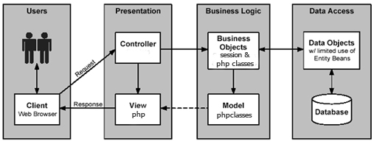

Fig: Architecture used

Four Tier architecture is a [client–server architecture](https://en.wikipedia.org/wiki/Client%E2%80%93server_architecture) in which presentation, application processing, and data management functions are physically separated. Four-tier application architecture provides a model by which developers can create flexible and reusable applications. By segregating an application into tiers, developers acquire the option of modifying or adding a specific layer, instead of reworking the entire application.

**5.2.1 Presentation layer**

This is the topmost level of the application. The presentation tier displays information related to such services as browsing merchandise, purchasing and shopping cart contents. It communicates with other tiers by which it puts out the results to the browser/client tier and all other tiers in the network. In simple terms, it is a layer which users can access directly (such as a web page, or an operating system's GUI).

**5.2.2 Business layer**

Business layer or domain logic is the part of the program that encodes the real-world [business rules](https://en.wikipedia.org/wiki/Business_rule) that determine how data can be [created, stored, and changed](https://en.wikipedia.org/wiki/Create,_read,_update_and_delete). It is contrasted with the remainder of the software that might be concerned with lower-level details of managing a [database](https://en.wikipedia.org/wiki/Database) or displaying the [user interface](https://en.wikipedia.org/wiki/User_interface), system infrastructure, or generally connecting various parts of the program.

**5.2.3 Data access layer**

A Data Access Layer (DAL) in computer software, is a [layer](https://en.wikipedia.org/wiki/Layer_(object-oriented_design)) of a [computer program](https://en.wikipedia.org/wiki/Computer_program) which provides simplified access to [data](https://en.wikipedia.org/wiki/Data) stored in [persistent storage](https://en.wikipedia.org/wiki/Persistent_storage).

For example, the DAL might return a reference to an [object](https://en.wikipedia.org/wiki/Object_(computer_science)) (in terms of [object-oriented programming](https://en.wikipedia.org/wiki/Object-oriented_programming)) complete with its attributes instead of a [row](https://en.wikipedia.org/wiki/Row_(database)) of [fields](https://en.wikipedia.org/wiki/Field_(computer_science)) from a database [table](https://en.wikipedia.org/wiki/Table_(database)). This allows the [client](https://en.wikipedia.org/wiki/Client_(computing)) (or user) modules to be created with a higher level of [abstraction](https://en.wikipedia.org/wiki/Abstraction). This kind of model could be implemented by creating a class of data access methods that directly reference a corresponding set of database stored procedures. Another implementation could potentially retrieve or write records to or from a file system. The DAL hides this complexity of the underlying data store from the external world.

**5.2.4 Control layer**

The control layer is responsible for communication between business and presentation layer. It connects the logic and data with each other and gives a better connectivity and separation between layers.

**CHAPTER 6**

**IMPLEMENTATION**

Index.php

<!DOCTYPE html>

<html>

<head>

<style>

.container {

position: relative;

text-align: center;

color: white;

}

.centered {

position: absolute;

color:black;

top: 50%;

left: 50%;

transform: translate(-50%, -50%);

}

button {

background-color: powderblue;

border: none;

color: black;

padding: 15px 32px;

text-align: center;

text-decoration: none;

font-size: 16px;

cursor: pointer;

}

</style>

</head>

<body>

<div class="container">

<img src="http://i67.tinypic.com/am8ajr.jpg" style="width:100%;">

<div class="centered">

<h1 align="center">ZOO DATABASE MANAGEMENT</h1>

<a href="login.php">

<button type="submit" name="submit" value="send" align="center"><b>Login</b></button>

</a>

</div>

</div>

</body>

</html>

home.php

<!DOCTYPE html>

<html>

<head>

<style>

.container {

position: relative;

text-align: center;

top: 420px;

color: white;

}

.centered {

position: absolute;

color:grey;

top: 80%;

left: 50%;

transform: translate(-50%, -50%);

}

button {

background-color: powderblue;

border: none;

color: black;

padding: 15px 32px;

text-align: center;

text-decoration: none;

font-size: 16px;

cursor: pointer;

}

h1 {

text-shadow: 2px 2px black;

}

body

{

background-image: url("http://i68.tinypic.com/2ajta4o.jpg");

}

</style>

</head>

<body>

<div class="container">

<div class="centered">

<br><br><br><br><br><br><br>

<h1 align="center">Home</h1>

<a href="index.php">

Logout</a>

</a>

<h2 align="left"><b>Employee Details</b><h2>

<a href="empdet.php">

<button type="submit" name="submit" value="send" align="left"><b>Insert</b></button></a>

</a>

<a href="displaying_data.php">

<button type="submit" name="submit" value="send" ><b>Delete/Update</b></button></a>

<a href="displaying_data.php">

<button type="submit" name="submit" value="send" align="left"><b>Display</b></button></a>

<h2 align="left"><b>Employee Shift Details</b><h2>

<a href="shift.php">

<button type="submit" name="submit" value="send" align="left"><b>Insert</b></button></a>

</a>

<a href="dushift.php">

<button type="submit" name="submit" value="send" ><b>Delete/Update</b></button></a>

<a href="dushift.php">

<button type="submit" name="submit" value="send" align="left"><b>Display</b></button></a>

</a>

<br><h2 align="left"><b>Department Details</b><h2>

</a>

<a href="dudept.php">

<button type="submit" name="submit" value="send" align="left"><b>Display</b></button></a>

</a>

<br><h2 align="left"><b>Manager Details</b><h2>

</a>

<a href="manager.php">

<button type="submit" name="submit" value="send" align="left"><b>Insert</b></button></a>

<a href="duadmin.php">

<button type="submit" name="submit" value="send" align="left"><b>Delete</b></button></a>

</a>

<a href="duadmin.php">

<button type="submit" name="submit" value="send" align="left"><b>Display</b></button></a>

<br><h2 align="left"><b>Zoo Population</b><h2>

<a href="duspecies.php">

<button type="submit" name="submit" value="send" align="left"><b>Display</b></button></a>

<a href="midspecies.php">

<button type="submit" name="submit" value="send" ><b>Update</b></button></a>

<br><h2 align="left"><b>Species Details</b><h2>

</a>

<a href="species_type.php">

<button type="submit" name="submit" value="send" align="left"><b>Insert</b></button></a>

<a href="duspeciesinformation.php">

<button type="submit" name="submit" value="send" align="left"><b>Delete/Update</b></button></a>

</a>

<a href="duspeciesinformation.php">

<button type="submit" name="submit" value="send" align="left"><b>Display</b></button></a>

<br><h2 align="left"><b>Amount collected</b><h2>

</a>

<a href="amt.php">

<button type="submit" name="submit" value="send" align="left"><b>Insert</b></button></a>

<a href="duaccount.php">

<button type="submit" name="submit" value="send" align="left"><b>Display</b></button></a>

<br><h2 align="left"><b>Display Min Max Sum from amount table</b><h2>

</a>

<a href="stored.php">

<button type="submit" name="submit" value="send" align="left"><b>Display</b></button></a>

</div>

</div>

</body>

</html>

login.php

<!DOCTYPE html>

<html>

<head>

<title>Login form</title>

<meta charset="utf-8">

<meta name="viewport" content="width=device-width, initial-scale=1">

<link rel="stylesheet" href="https://maxcdn.bootstrapcdn.com/bootstrap/3.3.7/css/bootstrap.min.css">

<script src="https://ajax.googleapis.com/ajax/libs/jquery/3.2.1/jquery.min.js"></script>

<script src="https://maxcdn.bootstrapcdn.com/bootstrap/3.3.7/js/bootstrap.min.js"></script>

</head>

</head>

<body>

<div id="frm">

<form action="processlogin.php" method="POST">

<h1 style="color:darkcyan;">ZOO DATABASE LOGIN</h1>

<p>

<label>Username:</label>

<input type="text" id="user" name="username" style="width:80%" />

</p>

<p>

<label>Password:</label>

<input type="password" id="pass" name="password" style="width:80%" />

</p>

<p>

<input type="submit" id=" btn " value="Login" />

</p>

</form>

</div>

<style>

body {

text-align: : center;

background: #eee;

background-color: lightsteelblue;

ime-mode: <img src="C:\Users\Amma\Downloads\th (10).jpe">;

}

#frm{

text-align: right;

margin: 100px auto;

text-align: center;

width: 20%;

font-size: 100%;

border-radius: 5px;

font-family: fantasy;

background-color:powderblue;

padding: 10px;

}

#h1{

text-align: center;

margin: 100px auto;

font-family: courier;

font-size: 100%;

color: blue;

padding: 10px;

}

}

#btn{

text-align: right;

text-align: center;

margin: 100px auto;

color: #fff;

font-family: courier;

font-size: 100%;

background: #3337ab7;

padding: 10px;

margin-left: 70%;

text-align: center;

padding: 70px;

}

</style>

</body>

</html>

Processlogin.php

<?php

$servername = "localhost";

$username = "root";

$password = "";

//Create connection

$conn = new mysqli($servername, $username, $password);

// Check connection

if ($conn->connect_error) {

die("Connection failed: " . $conn->connect_error);

}

mysqli_select_db($conn,"login");

// querry the database for user

$username = $_POST['username'];

$password = $_POST['password'];

//to prevent mysql injection;

$username = stripcslashes($username);

$password = stripcslashes($password);

$username = mysqli_real_escape_string($conn,$username);

$password = mysqli_real_escape_string($conn,$password);

$result = mysqli_query($conn,"select * from users where username = '$username' and password = '$password'")

or die("failed to query database".mysqli_error() );

$row = mysqli_fetch_array($result);

if($row['username'] == $username && $row['password'] == $password){

header("location:home.php");

}

else{

echo "<h1>Failed to login! Incorrect Userid or Password</h1>";

echo '<a href="login.php"><b>Back</b></a>';

}

?>

Empdet.php

<!DOCTYPE html>

<html lang="en">

<head>

<title>Employee Details</title>

<meta charset="utf-8">

<meta name="viewport" content="width=device-width, initial-scale=1">

<link rel="stylesheet" href="https://maxcdn.bootstrapcdn.com/bootstrap/3.3.7/css/bootstrap.min.css">

<script src="https://ajax.googleapis.com/ajax/libs/jquery/3.2.1/jquery.min.js"></script>

<script src="https://maxcdn.bootstrapcdn.com/bootstrap/3.3.7/js/bootstrap.min.js"></script>

</head>

<style>

div.container{

margin: 40px;

background-color: #ffffff;

opacity: 0.6;

filter: alpha(opacity=60); /* For IE8 and earlier */

}

body

{

background-image: url("http://i68.tinypic.com/2ajta4o.jpg");

}

div.form-group{

font-weight:bold;

color:black;

}

button {

background-color: powderblue;

border: none;

color: grey;

padding: 12px 30px;

text-align: center;

text-decoration: none;

display: inline-block;

font-size: 16px;

margin: 4px 2px;

cursor: pointer;

}

a {

text-decoration: none;

display: inline-block;

padding: 12px 16px;

}

a:hover {

background-color: #ddd;

color: black;

}

a.previous {

background-color: #f1f1f1;

color: black;

margin-left:650px;

margin-top:40px;

}

a.next {

background-color: powderblue;

color: black;

}

</style>

<body>

<div class="container">

<br><br><br>

<h2><b>Employee details</b></h2>

<b>

<form action="processempdet.php" method="POST">

<div class="form-group">

<label for="emp_id"><b>emp_id</b></label>

<input type="text" class="form-control" id="emp_id" placeholder="Enter id" name="emp_id" style="width:30%">

</div>

<div class="form-group">

<label for="fname">Fname</label>

<input type="text" class="form-control" id="fname" placeholder="Enter name" name="fname" style="width:30%">

</div>

<div class="form-group">

<label for="lname">Lname</label>

<input type="text" class="form-control" id="lname" placeholder="Enter name" name="lname" style="width:30%">

</div>

<div class="form-group">

<label for="doj">DOJ</label>

<input type="date" class="form-control" id="doj" placeholder="Enter doj" name="doj" style="width:30%">

</div>

<div class="form-group">

<label for="salary">Salary</label>

<input type="salary" class="form-control" id="salary" placeholder="Enter salary" name="salary" style="width:30%">

</div>

<div class="form-group">

<label for="dep_no">Dep_no</label>

<input type="text" class="form-control" id="dep_no" placeholder="Enter dep_no" name="dep_no" style="width:30%">

</div>

<div class="form-group">

<label for="sex">Sex</label>

<input type="text" class="form-control" id="sex" placeholder="Enter sex" name="sex" style="width:30%">

</div>

<div class="form-group">

<label for="ph_no">Mobile number</label>

<input type="telenumber" class="form-control" id="mbl_no" placeholder="Enter emp_id number" name="ph_no" style="width:30%">

</div>

&nbsp;&nbsp;&nbsp;&nbsp;&nbsp;&nbsp;&nbsp;&nbsp;&nbsp;&nbsp;&nbsp;&nbsp;&nbsp;&nbsp;&nbsp;&nbsp;&nbsp;&nbsp;&nbsp;&nbsp;&nbsp;&nbsp;&nbsp;&nbsp;&nbsp;&nbsp;&nbsp;&nbsp;&nbsp;&nbsp;&nbsp;&nbsp;

<button type="submit" name="submit" value="submit"><b>Submit</b></button>

<a href="home.php" class="previous">&laquo; Home</a>

<a href="shift.php" class="next">Next &raquo;</a>

</form>

</div>

</body>

</html>

Processempdet.php

<?php

$connect=mysqli_connect("localhost","root","","zoodb") or die('error');

$emp_id=$_POST['emp_id'];

$fname=$_POST['fname'];

$lname=$_POST['lname'];

$doj=$_POST['doj'];

$salary=$_POST['salary'];

$dep_no=$_POST['dep_no'];

$sex=$_POST['sex'];

$ph_no=$_POST['ph_no'];

$sql= "INSERT into emp (emp_id,fname,lname,doj,salary,dep_no,sex,ph_no) values('".$emp_id."','".$fname."','".$lname."','".$doj."','".$salary."','".$dep_no."','".$sex."','".$ph_no."')";

$query=mysqli_query($connect,$sql) or die(mysqli_error($connect));

if(isset($_POST['submit']))

{

header("location:empdet.php");

}

?>

Manager.php

<!DOCTYPE html>

<html lang="en">

<head>

<title>Manager Details</title>

<meta charset="utf-8">

<meta name="viewport" content="width=device-width, initial-scale=1">

<link rel="stylesheet" href="https://maxcdn.bootstrapcdn.com/bootstrap/3.3.7/css/bootstrap.min.css">

<script src="https://ajax.googleapis.com/ajax/libs/jquery/3.2.1/jquery.min.js"></script>

<script src="https://maxcdn.bootstrapcdn.com/bootstrap/3.3.7/js/bootstrap.min.js"></script>

</head>

<style>

div.container{

margin: 40px;

background-color: #ffffff;

opacity: 0.6;

filter: alpha(opacity=60); /* For IE8 and earlier */

}

body

{

background-image: url("http://i68.tinypic.com/2ajta4o.jpg");

}

div.form-group{

font-weight:bold;

color:black;

}

button {

background-color: powderblue;

border: none;

color: grey;

padding: 12px 30px;

text-align: center;

text-decoration: none;

display: inline-block;

font-size: 16px;

margin: 4px 2px;

cursor: pointer;

}

a {

text-decoration: none;

display: inline-block;

padding: 12px 16px;

}

a:hover {

background-color: #ddd;

color: black;

}

a.previous {

background-color: #f1f1f1;

color: black;

margin-left:650px;

margin-top:40px;

}

a.next {

background-color: powderblue;

color: black;

}

</style>

<body>

<div class="container">

<br><br><br>

<h2><b>Manager details</b></h2>

<b>

<form action="processman.php" method="POST">

<div class="form-group">

<label for="emp_id"><b>Dep_no</b></label>

<input type="text" class="form-control" id="dep_no" placeholder="Enter Department Number" name="dep_no" style="width:30%">

</div>

<div class="form-group">

<label for="fname">Mgr_id</label>

<input type="text" class="form-control" id="mgr_id" placeholder="Enter Manager ID" name="mgr_id" style="width:30%">

</div>

<div class="form-group">

<label for="lname">Mgrname</label>

<input type="text" class="form-control" id="mgrname" placeholder="Enter Manager Name" name="mgrname" style="width:30%">

</div>

&nbsp;&nbsp;&nbsp;&nbsp;&nbsp;&nbsp;&nbsp;&nbsp;&nbsp;&nbsp;&nbsp;&nbsp;&nbsp;&nbsp;&nbsp;&nbsp;&nbsp;&nbsp;&nbsp;&nbsp;&nbsp;&nbsp;&nbsp;&nbsp;&nbsp;&nbsp;&nbsp;&nbsp;&nbsp;&nbsp;&nbsp;&nbsp;

<button type="submit" name="submit" value="submit"><b>Submit</b></button>

<a href="home.php" class="previous">&laquo; Home</a>

<a href="species_type.php" class="next">Next &raquo;</a>

</form>

</div>

</body>

</html>

Processman.php

<?php

$connect=mysqli_connect("localhost","root","","zoodb") or die('error');

$dep_no=$_POST['dep_no'];

$mgrname=$_POST['mgrname'];

$mgr_id=$_POST['mgr_id'];

$sql= "INSERT into manager(dep_no,mgr_id,mgrname) values('".$dep_no."','".$mgr_id."','".$mgrname."')";

$query=mysqli_query($connect,$sql) or die(mysqli_error($connect));

if(isset($_POST['submit']))

{

header("location:manager.php");

}

?>

Species.php

<!DOCTYPE html>

<html lang="en">

<head>

<title>Zoo database</title>

<meta charset="utf-8">

<meta name="viewport" content="width=device-width, initial-scale=1">

<link rel="stylesheet" href="https://maxcdn.bootstrapcdn.com/bootstrap/3.3.7/css/bootstrap.min.css">

<script src="https://ajax.googleapis.com/ajax/libs/jquery/3.2.1/jquery.min.js"></script>

<script src="https://maxcdn.bootstrapcdn.com/bootstrap/3.3.7/js/bootstrap.min.js"></script>

</head>

<style>

div.container{

margin: 40px;

background-color: #ffffff;

opacity: 0.6;

filter: alpha(opacity=60); /* For IE8 and earlier */

}

body

{

background-image: url("http://i68.tinypic.com/2ajta4o.jpg");

}

div.form-group{

font-weight:bold;

color:black;

}

button {

background-color: powderblue;

border: none;

color: grey;

padding: 12px 30px;

text-align: center;

text-decoration: none;

display: inline-block;

font-size: 16px;

margin: 4px 2px;

cursor: pointer;

}

a {

text-decoration: none;

display: inline-block;

padding: 12px 16px;

}

a:hover {

background-color: #ddd;

color: black;

}

a.previous {

background-color: #f1f1f1;

color: black;

margin-left:650px;

margin-top:40px;

}

a.next {

background-color: powderblue;

color: black;

}

</style>

<body>

<div class="container">

<br><br><br>

<h2>Amount details</h2>

<b>

<form action="processamt1.php" method="POST">

<div class="form-group">

<label for="date1">Date</label>

<input type="date" class="form-control" id="date1" placeholder="Enter date" name="date1" style="width:30%">

</div>

<div class="form-group">

<label for="amt_collected">Total Amount Collected</label>

<input type="number" class="form-control" id="amt_collected" placeholder="Enter Amount Collected" name="amt_collected" style="width:30%">

</div>

&nbsp;&nbsp;&nbsp;&nbsp;&nbsp;&nbsp;&nbsp;&nbsp;&nbsp;&nbsp;&nbsp;&nbsp;&nbsp;&nbsp;&nbsp;&nbsp;&nbsp;&nbsp;&nbsp;&nbsp;&nbsp;&nbsp;&nbsp;&nbsp;&nbsp;&nbsp;&nbsp;&nbsp;&nbsp;&nbsp;&nbsp;&nbsp;<button type="submit" name="submit" value="send">Submit</button>

<a href="home.php" class="previous">&laquo; Home</a>

</form>

</div>

</body>

</html>

Processspecies.php

<?php

$connect=mysqli_connect("localhost","root","","zoodb") or die('error');

$species_type=$_POST['species_type'];

$population=$_POST['population'];

$sql= "INSERT into species (species_type,population) values('".$species_type."','".$population."')";

$query=mysqli_query($connect,$sql) or die(mysqli_error($connect));

if(isset($_POST['submit']))

{

header("location:species.php");

}

?>

Species_type.php

<!DOCTYPE html>

<html lang="en">

<head>

<title>Employee Details</title>

<meta charset="utf-8">

<meta name="viewport" content="width=device-width, initial-scale=1">

<link rel="stylesheet" href="https://maxcdn.bootstrapcdn.com/bootstrap/3.3.7/css/bootstrap.min.css">

<script src="https://ajax.googleapis.com/ajax/libs/jquery/3.2.1/jquery.min.js"></script>

<script src="https://maxcdn.bootstrapcdn.com/bootstrap/3.3.7/js/bootstrap.min.js"></script>

</head>

<style>

div.container{

margin: 40px;

background-color: #ffffff;

opacity: 0.6;

filter: alpha(opacity=60); /* For IE8 and earlier */

}

body

{

background-image: url("http://i68.tinypic.com/2ajta4o.jpg");

}

div.form-group{

font-weight:bold;

color:black;

}

button {

background-color: powderblue;

border: none;

color: grey;

padding: 12px 30px;

text-align: center;

text-decoration: none;

display: inline-block;

font-size: 16px;

margin: 4px 2px;

cursor: pointer;

}

a {

text-decoration: none;

display: inline-block;

padding: 12px 16px;

}

a:hover {

background-color: #ddd;

color: black;

}

a.previous {

background-color: #f1f1f1;

color: black;

margin-left:650px;

margin-top:40px;

}

a.next {

background-color: powderblue;

color: black;

}

</style>

<body>

<div class="container">

<br><br><br>

<h2>species_type details</h2>

<b>

<form action="processtype.php" method="POST">

<div class="form-group">

<label for="srecies_id">Species_id</label>

<input type="text" class="form-control" id="species_id" placeholder="Enter species_id" name="species_id" style="width:30%">

</div>

<div class="form-group">

<label for="species_type">Species_type</label>

<input type="text" class="form-control" id="type" placeholder="Enter Species Type" name="type" style="width:30%">

</div>

<div class="form-group">

<label for="species_name">Species_name</label>

<input type="text" class="form-control" id="name" placeholder="Enter Species Name" name="name" style="width:30%">

</div>

<div class="form-group">

<label for="care_taker">Care_taker</label>

<input type="text" class="form-control" id="caretaker" placeholder="Enter Caretaker ID" name="caretaker" style="width:30%">

</div>

<div class="form-group">

<label for="d_o_a">Date Of Arrival</label>

<input type="date" class="form-control" id="d_o_a" placeholder="Enter Date Of Arrival" name="d_o_a" style="width:30%">

</div>

&nbsp;&nbsp;&nbsp;&nbsp;&nbsp;&nbsp;&nbsp;&nbsp;&nbsp;&nbsp;&nbsp;&nbsp;&nbsp;&nbsp;&nbsp;&nbsp;&nbsp;&nbsp;&nbsp;&nbsp;&nbsp;&nbsp;&nbsp;&nbsp;&nbsp;&nbsp;&nbsp;&nbsp;&nbsp;&nbsp;&nbsp;&nbsp;<button type="submit" name="submit" value="send">Submit</button>

<a href="home.php" class="previous">&laquo; Home</a>

<a href="amt1.php" class="next">Next &raquo;</a>

</form>

</div>

</body>

</html>

Processtype.php

<?php

$connect=mysqli_connect("localhost","root","","zoodb") or die('error');

$species_id=$_POST['species_id'];

$name=$_POST['name'];

$type=$_POST['type'];

$caretaker=$_POST['caretaker'];

$d_o_a=$_POST['d_o_a'];

$sql= "INSERT into speciesall(species_id,type,name,caretaker,d_o_a) values('".$species_id."','".$type."','".$name."','".$caretaker."','".$d_o_a."')";

$query=mysqli_query($connect,$sql) or die(mysqli_error($connect));

if(isset($_POST['submit']))

{

header("location:species_type.php");

}

?>

Shift.php

<!DOCTYPE html>

<html lang="en">

<head>

<title>Employee Details</title>

<meta charset="utf-8">

<meta name="viewport" content="width=device-width, initial-scale=1">

<link rel="stylesheet" href="https://maxcdn.bootstrapcdn.com/bootstrap/3.3.7/css/bootstrap.min.css">

<script src="https://ajax.googleapis.com/ajax/libs/jquery/3.2.1/jquery.min.js"></script>

<script src="https://maxcdn.bootstrapcdn.com/bootstrap/3.3.7/js/bootstrap.min.js"></script>

</head>

<style>

div.container{

margin: 40px;

background-color: #ffffff;

opacity: 0.6;

filter: alpha(opacity=60); /* For IE8 and earlier */

}

body

{

background-image: url("http://i68.tinypic.com/2ajta4o.jpg");

}

div.form-group{

font-weight:bold;

color:black;

}

button {

background-color: powderblue;

border: none;

color: grey;

padding: 12px 30px;

text-align: center;

text-decoration: none;

display: inline-block;

font-size: 16px;

margin: 4px 2px;

cursor: pointer;

}

a {

text-decoration: none;

display: inline-block;

padding: 12px 16px;

}

a:hover {

background-color: #ddd;

color: black;

}

a.previous {

background-color: #f1f1f1;

color: black;

margin-left:650px;

margin-top:40px;

}

a.next {

background-color: powderblue;

color: black;

}

</style>

<body>

<div class="container">

<br><br><br>

<h2>Employee Shift Details</h2>

<b>

<form action="processshift.php" method="POST">

<div class="form-group">

<label for="shift">Shift</label>

<input type="text" class="form-control" id="shift" placeholder="Enter Shift" name="shift" style="width:30%">

</div>

<div class="form-group">

<label for="emp_id">Emp_id</label>

<input type="text" class="form-control" id="emp_id" placeholder="Enter Employee ID" name="emp_id" style="width:30%">

</div>

<div class="form-group">

<label for="dep_no">Dep_no</label>

<input type="text" class="form-control" id="dept_no" placeholder="Enter Department Number" name="dep_no" style="width:30%">

</div>

&nbsp;&nbsp;&nbsp;&nbsp;&nbsp;&nbsp;&nbsp;&nbsp;&nbsp;&nbsp;&nbsp;&nbsp;&nbsp;&nbsp;&nbsp;&nbsp;&nbsp;&nbsp;&nbsp;&nbsp;&nbsp;&nbsp;&nbsp;&nbsp;&nbsp;&nbsp;&nbsp;&nbsp;&nbsp;&nbsp;&nbsp;&nbsp;<button type="submit" name="submit" value="send">Submit</button>

<a href="home.php" class="previous">&laquo; Home</a>

<a href="manager.php" class="next">Next &raquo;</a>

</form>

</div>

</body>

</html>

Processshift.php

<?php

$connect=mysqli_connect("localhost","root","","zoodb") or die('error');

$shift=$_POST['shift'];

$emp_id=$_POST['emp_id'];

$dep_no=$_POST['dep_no'];

$sql= "INSERT into shift (shift,emp_id,dep_no) values('".$shift."','".$emp_id."','".$dep_no."')";

$query=mysqli_query($connect,$sql) or die(mysqli_error($connect));

if(isset($_POST['submit']))

{

header("location:shift.php");

}

?>

Amt1.php

</style>

<body>

<div class="container">

<br><br><br>

<h2>Amount details</h2>

<b>

<form action="processamt1.php" method="POST">

<div class="form-group">

<label for="date1">Date</label>

<input type="date" class="form-control" id="date1" placeholder="Enter date" name="date1" style="width:30%">

</div>

<div class="form-group">

<label for="amt_collected">Total Amount Collected</label>

<input type="number" class="form-control" id="amt_collected" placeholder="Enter Amount Collected" name="amt_collected" style="width:30%">

</div>

&nbsp;&nbsp;&nbsp;&nbsp;&nbsp;&nbsp;&nbsp;&nbsp;&nbsp;&nbsp;&nbsp;&nbsp;&nbsp;&nbsp;&nbsp;&nbsp;&nbsp;&nbsp;&nbsp;&nbsp;&nbsp;&nbsp;&nbsp;&nbsp;&nbsp;&nbsp;&nbsp;&nbsp;&nbsp;&nbsp;&nbsp;&nbsp;<button type="submit" name="submit" value="send">Submit</button>

<a href="home.php" class="previous">&laquo; Home</a>

</form>

</div>

</body>

</html>

Processamt.php

<?php

$connect=mysqli_connect("localhost","root","","zoodb") or die('error');

$date1=$_POST['date'];

$money_collected=$_POST['amt_collected'];

$sql= "INSERT into amount (date1,amt_collected) values('".$date1."',

'".$money_collected."')";

$query=mysqli_query($connect,$sql) or die(mysqli_error($connect));

if(isset($_POST['submit']))

{

header("location:amt.php");

}

?>

duamount.php

<?php

$connect=mysqli_connect("localhost","root","","zoodb") or die('error');

$sql1= "SELECT * FROM amount";

$query=mysqli_query($connect,$sql1) or die(mysqli_error($connect));

//$query = mysqli_query($conn, $sql);

?>

<html>

<head>

<title>Displaying MySQL Data in HTML Table</title>

<style type="text/css">

body {

font-size: 15px;

color: #343d44;

font-family: "segoe-ui", "open-sans", tahoma, arial;

padding: 0;

margin: 0;

}

button {

background-color: powderblue;

border: none;

color: grey;

padding: 12px 30px;

text-align: center;

text-decoration: none;

display: inline-block;

font-size: 16px;

margin-left:650px;

cursor: pointer;

}

table {

margin: auto;

font-family: "Lucida Sans Unicode", "Lucida Grande", "Segoe Ui";

font-size: 12px;

}

h1 {

margin: 25px auto 0;

text-align: center;

text-transform: uppercase;

font-size: 17px;

}

table td {

transition: all .5s;

}

/* Table */

.data-table {

border-collapse: collapse;

font-size: 14px;

min-width: 537px;

}

.data-table th,

.data-table td {

border: 1px solid #e1edff;

padding: 7px 17px;

}

.data-table caption {

margin: 7px;

}

/* Table Header */

.data-table thead th {

background-color: #508abb;

color: #FFFFFF;

border-color: #6ea1cc !important;

text-transform: uppercase;

}

/* Table Body */

.data-table tbody td {

color: #353535;

}

.data-table tbody td:first-child,

.data-table tbody td:nth-child(4),

.data-table tbody td:last-child {

text-align: right;

}

.data-table tbody tr:nth-child(odd) td {

background-color: #f4fbff;

}

.data-table tbody tr:hover td {

background-color: #ffffa2;

border-color: #ffff0f;

}

/* Table Footer */

.data-table tfoot th {

background-color: #e5f5ff;

text-align: right;

}

.data-table tfoot th:first-child {

text-align: left;

}

.data-table tbody td:empty

{

background-color: #ffcccc;

}

</style>

</head>

<body>

<h1>Table 7</h1>

<table class="data-table">

<caption class="title">Amount Collected</caption>

<tbody>

<thead>

<tr>

<th>DATE</th>

<th>TOTAL AMMOUNT</th>

<th>UPDATE</th>

</tr>

</thead>

<?php

while ($row = mysqli_fetch_array($query))

{?>

<tr>

<td><?php echo $row[0];?></td>

<td><?php echo $row[1];?></td>

</tr>

<?php }

?>

</tbody>

</table>

<br><br><br>

<a href="home.php">

<button type="submit" name="submit" value="send" align="center">Home</button>

</a>

</body>

</html>

Displaying_data.php

<?php

$db_host = 'localhost'; // Server Name

$db_user = 'root'; // Username

$db_pass = ''; // Password

$db_name = 'zoodb'; // Database Name

$mysqli = new mysqli($db_host, $db_user, $db_pass, $db_name);

if ($mysqli->connect_error) {

die ('Failed to connect to MySQL: ' . $mysqli->mysqli_connect_error);

}

$query = $mysqli->query("SELECT *

FROM emp");

//$query = mysqli_query($conn, $sql);

if (!$query) {

die ('SQL Error: ' . mysqli_error($conn));

}

?>

<html>

<head>

<title>Displaying MySQL Data in HTML Table</title>

<style type="text/css">

body {

font-size: 15px;

color: #343d44;

font-family: "segoe-ui", "open-sans", tahoma, arial;

padding: 0;

margin: 0;

}

button {

background-color: powderblue;

border: none;

color: grey;

padding: 12px 30px;

text-align: center;

text-decoration: none;

display: inline-block;

font-size: 16px;

margin-left:650px;

cursor: pointer;

}

table {

margin: auto;

font-family: "Lucida Sans Unicode", "Lucida Grande", "Segoe Ui";

font-size: 12px;

}

h1 {

margin: 25px auto 0;

text-align: center;

text-transform: uppercase;

font-size: 17px;

}

table td {

transition: all .5s;

}

/* Table */

.data-table {

border-collapse: collapse;

font-size: 14px;

min-width: 537px;

}

.data-table th,

.data-table td {

border: 1px solid #e1edff;

padding: 7px 17px;

}

.data-table caption {

margin: 7px;

}

/* Table Header */

.data-table thead th {

background-color: #508abb;

color: #FFFFFF;

border-color: #6ea1cc !important;

text-transform: uppercase;

}

/* Table Body */

.data-table tbody td {

color: #353535;

}

.data-table tbody td:first-child,

.data-table tbody td:nth-child(4),

.data-table tbody td:last-child {

text-align: right;

}

.data-table tbody tr:nth-child(odd) td {

background-color: #f4fbff;

}

.data-table tbody tr:hover td {

background-color: #ffffa2;

border-color: #ffff0f;

}

/* Table Footer */

.data-table tfoot th {

background-color: #e5f5ff;

text-align: right;

}

.data-table tfoot th:first-child {

text-align: left;

}

.data-table tbody td:empty

{

background-color: #ffcccc;

}

</style>

</head>

<body>

<h1>Table 1</h1>

<table class="data-table">

<caption class="title">EMPLOYEE DETAILS</caption>

<tbody>

<thead>

<tr>

<th>EMP_ID</th>

<th>FNAME</th>

<th>LNAME</th>

<th>DOJ</th>

<th>SALARY</th>

<th>DEP_NO</th>

<th>SEX</th>

<th>PH_NO</th>

<th>DELETE</th>

<th>UPDATE</th>

</tr>

</thead>

<?php

while ($row = mysqli_fetch_array($query))

{?>

<tr>

<td><?php echo $row[0];?></td>

<td><?php echo $row[1];?></td>

<td><?php echo $row[2];?></td>

<td><?php echo $row[3];?></td>

<td><?php echo $row[4];?></td>

<td><?php echo $row[5];?></td>

<td><?php echo $row[6];?></td>

<td><?php echo $row[7];?></td>

<td><a href="deleteemp.php?emp_id=<?php echo $row[0];?> " >delete</a></td>

<td><a href="midemp.php?emp_id=<?php echo $row[0];?>">update</a></td>

</tr>

<?php }

?>

</tbody>

</table>

<br><br><br>

<a href="home.php">

<button type="submit" name="submit" value="send" align="center">Home</button>

</a>

</form>

</body>

</html>

Duspecies.php

<?php

$connect=mysqli_connect("localhost","root","","zoodb") or die('error');

$sql1= "SELECT * FROM species";

$query=mysqli_query($connect,$sql1) or die(mysqli_error($connect));

//$query = mysqli_query($conn, $sql);

?>

<html>

<head>

<title>Displaying MySQL Data in HTML Table</title>

<style type="text/css">

body {

font-size: 15px;

color: #343d44;

font-family: "segoe-ui", "open-sans", tahoma, arial;

padding: 0;

margin: 0;

}

button {

background-color: powderblue;

border: none;

color: grey;

padding: 12px 30px;

text-align: center;

text-decoration: none;

display: inline-block;

font-size: 16px;

margin-left:650px;

cursor: pointer;

}

table {

margin: auto;

font-family: "Lucida Sans Unicode", "Lucida Grande", "Segoe Ui";

font-size: 12px;

}

h1 {

margin: 25px auto 0;

text-align: center;

text-transform: uppercase;

font-size: 17px;

}

table td {

transition: all .5s;

}

/* Table */

.data-table {

border-collapse: collapse;

font-size: 14px;

min-width: 537px;

}

.data-table th,

.data-table td {

border: 1px solid #e1edff;

padding: 7px 17px;

}

.data-table caption {

margin: 7px;

}

/* Table Header */

.data-table thead th {

background-color: #508abb;

color: #FFFFFF;

border-color: #6ea1cc !important;

text-transform: uppercase;

}

/* Table Body */

.data-table tbody td {

color: #353535;

}

.data-table tbody td:first-child,

.data-table tbody td:nth-child(4),

.data-table tbody td:last-child {

text-align: right;

}

.data-table tbody tr:nth-child(odd) td {

background-color: #f4fbff;

}

.data-table tbody tr:hover td {

background-color: #ffffa2;

border-color: #ffff0f;

}

/* Table Footer */

.data-table tfoot th {

background-color: #e5f5ff;

text-align: right;

}

.data-table tfoot th:first-child {

text-align: left;

}

.data-table tbody td:empty

{

background-color: #ffcccc;

}

</style>

</head>

<body>

<h1>Table 5</h1>

<table class="data-table">

<caption class="title">Zoo Population</caption>

<tbody>

<thead>

<tr>

<th>SPECIES_TYPE</th>

<th>POPULATION</th>

<th>UPDATE</th>

</tr>

</thead>

<?php

while ($row = mysqli_fetch_array($query))

{?>

<tr>

<td><?php echo $row[0];?></td>

<td><?php echo $row[1];?></td>

<td><a href="midspecies.php?species_type=<?php echo $row[0];?>">update</a></td>

</tr>

<?php }

?>

</tbody>

</table>

<br><br><br>

<a href="home.php">

<button type="submit" name="submit" value="send" align="center">Home</button>

</a>

</body>

</html>

Duspeciesinformation.php

<?php

$connect=mysqli_connect("localhost","root","","zoodb") or die('error');

$sql1= "SELECT * FROM speciesall";

$query=mysqli_query($connect,$sql1) or die(mysqli_error($connect));

//$query = mysqli_query($conn, $sql);

?>

<html>

<head>

<title>Displaying MySQL Data in HTML Table</title>

<style type="text/css">

body {

font-size: 15px;

color: #343d44;

font-family: "segoe-ui", "open-sans", tahoma, arial;

padding: 0;

margin: 0;

}

button {

background-color: powderblue;

border: none;

color: grey;

padding: 12px 30px;

text-align: center;

text-decoration: none;

display: inline-block;

font-size: 16px;

margin-left:650px;

cursor: pointer;

}

table {

margin: auto;

font-family: "Lucida Sans Unicode", "Lucida Grande", "Segoe Ui";

font-size: 12px;

}

h1 {

margin: 25px auto 0;

text-align: center;

text-transform: uppercase;

font-size: 17px;

}

table td {

transition: all .5s;

}

/* Table */

.data-table {

border-collapse: collapse;

font-size: 14px;

min-width: 537px;

}

.data-table th,

.data-table td {

border: 1px solid #e1edff;

padding: 7px 17px;

}

.data-table caption {

margin: 7px;

}

/* Table Header */

.data-table thead th {

background-color: #508abb;

color: #FFFFFF;

border-color: #6ea1cc !important;

text-transform: uppercase;

}

/* Table Body */

.data-table tbody td {

color: #353535;

}

.data-table tbody td:first-child,

.data-table tbody td:nth-child(4),

.data-table tbody td:last-child {

text-align: right;

}

.data-table tbody tr:nth-child(odd) td {

background-color: #f4fbff;

}

.data-table tbody tr:hover td {

background-color: #ffffa2;

border-color: #ffff0f;

}

/* Table Footer */

.data-table tfoot th {

background-color: #e5f5ff;

text-align: right;

}

.data-table tfoot th:first-child {

text-align: left;

}

.data-table tbody td:empty

{

background-color: #ffcccc;

}

</style>

</head>

<body>

<h1>Table 1</h1>

<table class="data-table">

<caption class="title">SPECIES_INFORMATION</caption>

<tbody>

<thead>

<tr>

<th>SPECIES_ID</th>

<th>SPECIES_NAME</th>

<th>SPECIES_TYPE</th>

<th>CARETAKER_ID</th>

<th>DOA</th>

<th>DELETE</th>

<TH>UPDATE</TH>

</tr>

</thead>

<?php

while ($row = mysqli_fetch_array($query))

{?>

<tr>

<td><?php echo $row[0];?></td>

<td><?php echo $row[1];?></td>

<td><?php echo $row[2];?></td>

<td><?php echo $row[3];?></td>

<td><?php echo $row[4];?></td>

<td><a href="deletespeciesinfo.php?species_id=<?php echo $row[0];?> " >delete</a></td>

<td><a href="midinfo.php?species_id=<?php echo $row[0];?>">update</a></td>

</tr>

<?php }

?>

</tbody>

</table>

<br><br><br>

<a href="home.php">

<button type="submit" name="submit" value="send" align="center">Home</button>

</a>

</body>

</html>

Dushift.php

<?php

$connect=mysqli_connect("localhost","root","","zoodb") or die('error');

$sql1= "SELECT * FROM shift";

$query=mysqli_query($connect,$sql1) or die(mysqli_error($connect));

//$query = mysqli_query($conn, $sql);

?>

<html>

<head>

<title>Displaying MySQL Data in HTML Table</title>

<style type="text/css">

body {

font-size: 15px;

color: #343d44;

font-family: "segoe-ui", "open-sans", tahoma, arial;

padding: 0;

margin: 0;

}

button {

background-color: powderblue;

border: none;

color: grey;

padding: 12px 30px;

text-align: center;

text-decoration: none;

display: inline-block;

font-size: 16px;

margin-left:650px;

cursor: pointer;

}

table {

margin: auto;

font-family: "Lucida Sans Unicode", "Lucida Grande", "Segoe Ui";

font-size: 12px;

}

h1 {

margin: 25px auto 0;

text-align: center;

text-transform: uppercase;

font-size: 17px;

}

table td {

transition: all .5s;

}

/* Table */

.data-table {

border-collapse: collapse;

font-size: 14px;

min-width: 537px;

}

.data-table th,

.data-table td {

border: 1px solid #e1edff;

padding: 7px 17px;

}

.data-table caption {

margin: 7px;

}

/* Table Header */

.data-table thead th {

background-color: #508abb;

color: #FFFFFF;

border-color: #6ea1cc !important;

text-transform: uppercase;

}

/* Table Body */

.data-table tbody td {

color: #353535;

}

.data-table tbody td:first-child,

.data-table tbody td:nth-child(4),

.data-table tbody td:last-child {

text-align: right;

}

.data-table tbody tr:nth-child(odd) td {

background-color: #f4fbff;

}

.data-table tbody tr:hover td {

background-color: #ffffa2;

border-color: #ffff0f;

}

/* Table Footer */

.data-table tfoot th {

background-color: #e5f5ff;

text-align: right;

}

.data-table tfoot th:first-child {

text-align: left;

}

.data-table tbody td:empty

{

background-color: #ffcccc;

}

</style>

</head>

<body>

<h1>Table 2</h1>

<table class="data-table">

<caption class="title">SHIFT</caption>

<tbody>

<thead>

<tr>

<th>SHIFT</th>

<th>EMP_ID</th>

<th>DEP_NO</th>

<th>DELETE</th>

<th>UPDATE</th>

</tr>

</thead>

<?php

while ($row = mysqli_fetch_array($query))

{?>

<tr>

<td><?php echo $row[0];?></td>

<td><?php echo $row[1];?></td>

<td><?php echo $row[2];?></td>

<td><a href="deleteshift.php?emp_id=<?php echo $row[1];?>">delete</a></td>

<td><a href="midshift.php?emp_id=<?php echo $row[1];?>">update</a></td>

</tr>

<?php }

?>

</tbody>

</table>

<br><br><br>

<a href="home.php">

<button type="submit" name="submit" value="send" align="center">Home</button>

</a>

</body>

</html>

Dudept.php

<?php

$db_host = 'localhost'; // Server Name

$db_user = 'root'; // Username

$db_pass = ''; // Password

$db_name = 'zoodb'; // Database Name

$mysqli = new mysqli($db_host, $db_user, $db_pass, $db_name);

if ($mysqli->connect_error) {

die ('Failed to connect to MySQL: ' . $mysqli->mysqli_connect_error);

}

$query = $mysqli->query("SELECT *

FROM department");

//$query = mysqli_query($conn, $sql);

if (!$query) {

die ('SQL Error: ' . mysqli_error($conn));

}

?>

<html>

<head>

<title>Displaying MySQL Data in HTML Table</title>

<style type="text/css">

body {

font-size: 15px;

color: #343d44;

font-family: "segoe-ui", "open-sans", tahoma, arial;

padding: 0;

margin: 0;

}

button {

background-color: powderblue;

border: none;

color: grey;

padding: 12px 30px;

text-align: center;

text-decoration: none;

display: inline-block;

font-size: 16px;

margin-left:650px;

cursor: pointer;

}

table {

margin: auto;

font-family: "Lucida Sans Unicode", "Lucida Grande", "Segoe Ui";

font-size: 12px;

}

h1 {

margin: 25px auto 0;

text-align: center;

text-transform: uppercase;

font-size: 17px;

}

table td {

transition: all .5s;

}

/* Table */

.data-table {

border-collapse: collapse;

font-size: 14px;

min-width: 537px;

}

.data-table th,

.data-table td {

border: 1px solid #e1edff;

padding: 7px 17px;

}

.data-table caption {

margin: 7px;

}

/* Table Header */

.data-table thead th {

background-color: #508abb;

color: #FFFFFF;

border-color: #6ea1cc !important;

text-transform: uppercase;

}

/* Table Body */

.data-table tbody td {

color: #353535;

}

.data-table tbody td:first-child,

.data-table tbody td:nth-child(4),

.data-table tbody td:last-child {

text-align: right;

}

.data-table tbody tr:nth-child(odd) td {

background-color: #f4fbff;

}

.data-table tbody tr:hover td {

background-color: #ffffa2;

border-color: #ffff0f;

}

/* Table Footer */

.data-table tfoot th {

background-color: #e5f5ff;

text-align: right;

}

.data-table tfoot th:first-child {

text-align: left;

}

.data-table tbody td:empty

{

background-color: #ffcccc;

}

</style>

</head>

<body>

<h1>Table 3</h1>

<table class="data-table">

<caption class="title">DEPARTMENT DETAILS</caption>

<tbody>

<thead>

<tr>

<th>DEP_NO</th>

<th>Dep_NAME</th>

</tr>

</thead>

<?php

while ($row = mysqli_fetch_array($query))

{?>

<tr>

<td><?php echo $row[0];?></td>

<td><?php echo $row[1];?></td>

</tr>

<?php }

?>

</tbody>

</table>

<br><br><br>

<a href="home.php">

<button type="submit" name="submit" value="send" align="center">Home</button>

</a>

</form>

</body>

</html>

Duadmin.php

<?php

$connect=mysqli_connect("localhost","root","","zoodb") or die('error');

$sql1= "SELECT * FROM manager";

$query=mysqli_query($connect,$sql1) or die(mysqli_error($connect));

//$query = mysqli_query($conn, $sql);

?>

<html>

<head>

<title>Displaying MySQL Data in HTML Table</title>

<style type="text/css">

body {

font-size: 15px;

color: #343d44;

font-family: "segoe-ui", "open-sans", tahoma, arial;

padding: 0;

margin: 0;

}

button {

background-color: powderblue;

border: none;

color: grey;

padding: 12px 30px;

text-align: center;

text-decoration: none;

display: inline-block;

font-size: 16px;

margin-left:650px;

cursor: pointer;

}

table {

margin: auto;

font-family: "Lucida Sans Unicode", "Lucida Grande", "Segoe Ui";

font-size: 12px;

}

h1 {

margin: 25px auto 0;

text-align: center;

text-transform: uppercase;

font-size: 17px;

}

table td {

transition: all .5s;

}

/* Table */

.data-table {

border-collapse: collapse;

font-size: 14px;

min-width: 537px;

}

.data-table th,

.data-table td {

border: 1px solid #e1edff;

padding: 7px 17px;

}

.data-table caption {

margin: 7px;

}

/* Table Header */

.data-table thead th {

background-color: #508abb;

color: #FFFFFF;

border-color: #6ea1cc !important;

text-transform: uppercase;

}

/* Table Body */

.data-table tbody td {

color: #353535;

}

.data-table tbody td:first-child,

.data-table tbody td:nth-child(4),

.data-table tbody td:last-child {

text-align: right;

}

.data-table tbody tr:nth-child(odd) td {

background-color: #f4fbff;

}

.data-table tbody tr:hover td {

background-color: #ffffa2;

border-color: #ffff0f;

}

/* Table Footer */

.data-table tfoot th {

background-color: #e5f5ff;

text-align: right;

}

.data-table tfoot th:first-child {

text-align: left;

}

.data-table tbody td:empty

{

background-color: #ffcccc;

}

</style>

</head>

<body>

<h1>Table 4</h1>

<table class="data-table">

<caption class="title">Manager Details</caption>

<tbody>

<thead>

<tr>

<th>DEP_NO</th>

<th>MANAGER_ID</th>

<th>MANAGER_NAME</th>

<th>DELETE</th>

</tr>

</thead>

<?php

while ($row = mysqli_fetch_array($query))

{?>

<tr>

<td><?php echo $row[0];?></td>

<td><?php echo $row[1];?></td>

<td><?php echo $row[2];?></td>

<td><a href="deleteadmin.php?mgr_id=<?php echo $row[1];?> " >delete</a></td>

</tr>

<?php }

?>

</tbody>

</table>

<br><br><br>

<a href="home.php">

<button type="submit" name="submit" value="send" align="center">Home</button>

</a>

</body>

</html>

Deleteemp.php

<?php

$mysqli= new mysqli("localhost","root","","zoodb") or die('error');

//getting id of the data from url

$id = $_GET['emp_id'];

$result=$mysqli->query("DELETE FROM emp WHERE emp_id = '$id' " ) or die(mysqli_error($mysqli));

if($result)

{

header("location:displaying_data.php");

}

else{

echo 'fail';

}

?>

Deleteadmin.php

<?php

$mysqli= new mysqli("localhost","root","","zoodb") or die('error');

//getting id of the data from url

//echo 'success';

$id= $_GET['mgr_id'];

$result=$mysqli->query("DELETE FROM manager WHERE mgr_id = '$id' " ) or die(mysqli_error($mysqli));

if($result)

{

header("location:duadmin.php");

}

else{

echo 'fail';

}

?>

Deleteshift.php

<?php

$mysqli= new mysqli("localhost","root","","zoodb") or die('error');

$id = $_GET['emp_id'];

$result=$mysqli->query("DELETE FROM shift WHERE emp_id = '$id' " ) or die(mysqli_error($mysqli));

if($result)

{

header("location:dushift.php");

}

else{

echo 'fail';

}

?>

Deletspeciesinfo.php

<?php

$mysqli= new mysqli("localhost","root","","zoodb") or die('error');

//getting id of the data from url

//echo 'success';

$species_id=$_GET['species_id'];

$result=$mysqli->query("DELETE FROM speciesall WHERE species_id = '$species_id' " ) or die(mysqli_error($mysqli));

if($result)

{

header("location:duspeciesinformation.php");

}

else{

echo 'fail';

}

?>

Midaccount.php

<?php

$connect=mysqli_connect("localhost","root","","zoodb") or die('error');

mysqli_select_db($connect,"zoodb");

// querry the database for user

?>

<!DOCTYPE html>

<html lang="en">

<head>

<title> Update</title>

<meta charset="utf-8">

<meta name="viewport" content="width=device-width, initial-scale=1">

<link rel="stylesheet" href="https://maxcdn.bootstrapcdn.com/bootstrap/3.3.7/css/bootstrap.min.css">

<script src="https://ajax.googleapis.com/ajax/libs/jquery/3.2.1/jquery.min.js"></script>

<script src="https://maxcdn.bootstrapcdn.com/bootstrap/3.3.7/js/bootstrap.min.js"></script>

</head>

<style>

body

{

background-image: url("man.jpg");

background-size:cover;

}

</style>

<body>

<div class="container">

<br><br><br>

<h2>Ammount <ACRONYM></ACRONYM></h2>

<b>

<form action=updateaccount.php" method="POST">

<div class="form-group">

<div class="form-group">

<label for="date">date</label>

<input type="date" class="form-control" id='date1' name="date" placeholder='enter date' style="width:30%" required="date1">

</div>

<div class="form-group">

<label for="total_ammount">total_amount</label>

<input type="number" class="form-control" id='total_amount' name="total_amount" placeholder='enter total amount' style="width:30%">

</div>

&nbsp;&nbsp;&nbsp;&nbsp;&nbsp;&nbsp;&nbsp;&nbsp;&nbsp;&nbsp;&nbsp;&nbsp;&nbsp;&nbsp;&nbsp;&nbsp;&nbsp;&nbsp;&nbsp;&nbsp;&nbsp;&nbsp;&nbsp;&nbsp;&nbsp;&nbsp;&nbsp;&nbsp;&nbsp;&nbsp;&nbsp;&nbsp;<button type="submit" name="submit" value="send">Submit</button>

</form>

</div>

</body>

</html>

Midadmin.php

<?php

$connect=mysqli_connect("localhost","root","","zoodb") or die('error');

mysqli_select_db($connect,"zoodb");

// querry the database for user

?>

<!DOCTYPE html>

<html lang="en">

<head>

<title> Update</title>

<meta charset="utf-8">

<meta name="viewport" content="width=device-width, initial-scale=1">

<link rel="stylesheet" href="https://maxcdn.bootstrapcdn.com/bootstrap/3.3.7/css/bootstrap.min.css">

<script src="https://ajax.googleapis.com/ajax/libs/jquery/3.2.1/jquery.min.js"></script>

<script src="https://maxcdn.bootstrapcdn.com/bootstrap/3.3.7/js/bootstrap.min.js"></script>

</head>

<style>

body

{

background-image: url("man.jpg");

background-size:cover;

}

</style>

<body>

<div class="container">

<br><br><br>

<h2>Admin <ACRONYM></ACRONYM></h2>

<b>

<form action=updateadmin.php" method="POST">

<div class="form-group">

<div class="form-group">

<label for="dep_no">dep_no</label>

<input type="text" class="form-control" id='dep_no' name="dep_no" placeholder='$dep_no' style="width:30%" required="dep_no">

</div>

<div class="form-group">

<label for="mngr_id">mngr_id</label>

<input type="text" class="form-control" id='$mngr_id' name="mgr_id" placeholder='$mgr_id' style="width:30%">

</div>

<label for="mngr_name">admin_name</label>

<input type="text" class="form-control" id="mgrname" placeholder="Enter mngr_name" name="mgrname" style="width:30%" >

</div>

&nbsp;&nbsp;&nbsp;&nbsp;&nbsp;&nbsp;&nbsp;&nbsp;&nbsp;&nbsp;&nbsp;&nbsp;&nbsp;&nbsp;&nbsp;&nbsp;&nbsp;&nbsp;&nbsp;&nbsp;&nbsp;&nbsp;&nbsp;&nbsp;&nbsp;&nbsp;&nbsp;&nbsp;&nbsp;&nbsp;&nbsp;&nbsp;<button type="submit" name="submit" value="send">Submit</button>

</form>

</div>

</body>

</html>

Midemp.php

<?php

$connect=mysqli_connect("localhost","root","","zoodb") or die('error');

mysqli_select_db($connect,"zoodb");

// querry the database for user

?>

<!DOCTYPE html>

<html lang="en">

<head>

<title>Employee details</title>

<meta charset="utf-8">

<meta name="viewport" content="width=device-width, initial-scale=1">

<link rel="stylesheet" href="https://maxcdn.bootstrapcdn.com/bootstrap/3.3.7/css/bootstrap.min.css">

<script src="https://ajax.googleapis.com/ajax/libs/jquery/3.2.1/jquery.min.js"></script>

<script src="https://maxcdn.bootstrapcdn.com/bootstrap/3.3.7/js/bootstrap.min.js"></script>

</head>

<style>

body

{

background-image: url("man.jpg");

background-size:cover;

}

</style>

<body>

<div class="container">

<br><br><br>

<h2>Employee</h2>

<b>

<form action="updateemp.php" method="POST">

<div class="form-group">

<div class="form-group">

<label for="emp_id">emp_id</label>

<input type="text" class="form-control" id='emp_id' name="emp_id" placeholder="enter emp_id" style="width:30%" required="emp_id">

</div>

<label for="salary">salary</label>

<input type="number" class="form-control" id="salary" placeholder="Enter salary" name="salary" style="width:30%" >

</div>

<div class="form-group">

<label for="phone_no">phone_no</label>

<input type="telenumber" class="form-control" id="ph_no" placeholder="Enter phone_no" name="ph_no" style="width:30%" >

</div>

&nbsp;&nbsp;&nbsp;&nbsp;&nbsp;&nbsp;&nbsp;&nbsp;&nbsp;&nbsp;&nbsp;&nbsp;&nbsp;&nbsp;&nbsp;&nbsp;&nbsp;&nbsp;&nbsp;&nbsp;&nbsp;&nbsp;&nbsp;&nbsp;&nbsp;&nbsp;&nbsp;&nbsp;&nbsp;&nbsp;&nbsp;&nbsp;<button type="submit" name="submit" value="send">Submit</button>

</form>

</div>

</body>

</html>

Midinfo.php

<?php

$connect=mysqli_connect("localhost","root","","zoodb") or die('error');

mysqli_select_db($connect,"zoodb");

// querry the database for user

?>

<!DOCTYPE html>

<html lang="en">

<head>

<title>UPDATE</title>

<meta charset="utf-8">

<meta name="viewport" content="width=device-width, initial-scale=1">

<link rel="stylesheet" href="https://maxcdn.bootstrapcdn.com/bootstrap/3.3.7/css/bootstrap.min.css">

<script src="https://ajax.googleapis.com/ajax/libs/jquery/3.2.1/jquery.min.js"></script>

<script src="https://maxcdn.bootstrapcdn.com/bootstrap/3.3.7/js/bootstrap.min.js"></script>

</head>

<style>

body

{

background-image: url("man.jpg");

background-size:cover;

}

</style>

<body>

<div class="container">

<br><br><br>

<h2>Update</h2>

<b>

<form action="updateinfo.php" method="POST">

<div class="form-group">

<div class="form-group">

<label for="species_id">species_id</label>

<input type="text" class="form-control" id="species_id" placeholder="Enter species_id" name="species_id" style="width:30%" >

</div>

<div class="form-group">

<label for="caretaker_id">caretaker_id</label>

<input type="text" class="form-control" id="caretaker_id" placeholder="Enter caretaker_id" name="caretaker" style="width:30%" >

</div>

&nbsp;&nbsp;&nbsp;&nbsp;&nbsp;&nbsp;&nbsp;&nbsp;&nbsp;&nbsp;&nbsp;&nbsp;&nbsp;&nbsp;&nbsp;&nbsp;&nbsp;&nbsp;&nbsp;&nbsp;&nbsp;&nbsp;&nbsp;&nbsp;&nbsp;&nbsp;&nbsp;&nbsp;&nbsp;&nbsp;&nbsp;&nbsp;<button type="submit" name="submit" value="send">Submit</button>

</form>

</div>

</body>

</html>

Midshift.php

<?php

$connect=mysqli_connect("localhost","root","","zoodb") or die('error');

mysqli_select_db($connect,"zoodb");

// querry the database for user

?>

<!DOCTYPE html>

<html lang="en">

<head>

<title>Update</title>

<meta charset="utf-8">

<meta name="viewport" content="width=device-width, initial-scale=1">

<link rel="stylesheet" href="https://maxcdn.bootstrapcdn.com/bootstrap/3.3.7/css/bootstrap.min.css">

<script src="https://ajax.googleapis.com/ajax/libs/jquery/3.2.1/jquery.min.js"></script>

<script src="https://maxcdn.bootstrapcdn.com/bootstrap/3.3.7/js/bootstrap.min.js"></script>

</head>

<style>

body

{

background-image: url("man.jpg");

background-size:cover;

}

</style>

<body>

<div class="container">

<br><br><br>

<h2>Shift</h2>

<b>

<form action="updateshift.php" method="POST">

<div class="form-group">

<label for="emp_id">emp_id</label>

<input type="text" class="form-control" id="$emp_id" placeholder="Enter emp_id" name="emp_id" style="width:30%" required="emp_id" >

</div>

<div class="form-group">

<label for="shift">shift</label>

<input type="text" class="form-control" id="shift" name="shift" placeholder="Enter shift" style="width:30%">

</div>

&nbsp;&nbsp;&nbsp;&nbsp;&nbsp;&nbsp;&nbsp;&nbsp;&nbsp;&nbsp;&nbsp;&nbsp;&nbsp;&nbsp;&nbsp;&nbsp;&nbsp;&nbsp;&nbsp;&nbsp;&nbsp;&nbsp;&nbsp;&nbsp;&nbsp;&nbsp;&nbsp;&nbsp;&nbsp;&nbsp;&nbsp;&nbsp;<button type="submit" name="submit" value="send">Submit</button>

</form>

</div>

</body>

</html>

Midspecies.php

<?php

$connect=mysqli_connect("localhost","root","","zoodb") or die('error');

mysqli_select_db($connect,"zoodb");

// querry the database for user

?>

<!DOCTYPE html>

<html lang="en">

<head>

<title>UPDATE</title>

<meta charset="utf-8">

<meta name="viewport" content="width=device-width, initial-scale=1">

<link rel="stylesheet" href="https://maxcdn.bootstrapcdn.com/bootstrap/3.3.7/css/bootstrap.min.css">

<script src="https://ajax.googleapis.com/ajax/libs/jquery/3.2.1/jquery.min.js"></script>

<script src="https://maxcdn.bootstrapcdn.com/bootstrap/3.3.7/js/bootstrap.min.js"></script>

</head>

<style>

body

{

background-image: url("man.jpg");

background-size:cover;

}

</style>

<body>

<div class="container">

<br><br><br>

<h2>Species</h2>

<b>

<form action="updatespecies.php" method="POST">

<div class="form-group">

<div class="form-group">

<label for="Species_type">species_type</label>

<input type="text" class="form-control" id="species_type" placeholder="Enter species_type" name="species_type" style="width:30%" required="species_type" >

</div>

<div class="form-group">

<label for="Population">population</label>

<input type="number" class="form-control" id="population" placeholder="Enter population" name="population" style="width:30%" >

</div>

&nbsp;&nbsp;&nbsp;&nbsp;&nbsp;&nbsp;&nbsp;&nbsp;&nbsp;&nbsp;&nbsp;&nbsp;&nbsp;&nbsp;&nbsp;&nbsp;&nbsp;&nbsp;&nbsp;&nbsp;&nbsp;&nbsp;&nbsp;&nbsp;&nbsp;&nbsp;&nbsp;&nbsp;&nbsp;&nbsp;&nbsp;&nbsp;<button type="submit" name="submit" value="send">Submit</button>

</form>

</div>

</body>

</html>

Updateaccount.php

<?php

$mysqli= new mysqli("localhost","root","","zoodb") or die('error');

//getting id of the data from url

$species_type = $_POST['species_type'];

$population = $_POST['population'];

$result=$mysqli->query("UPDATE species set population='$population' where species_type='$species_type'")or die(mysqli_error($mysqli));

if($result)

{

header("location:duspecies.php");

}

else{

echo 'Fail to update';

}

?>

Updatespecies.php

<?php

$mysqli= new mysqli("localhost","root","","zoodb") or die('error');

//getting id of the data from url

$species_type = $_POST['species_type'];

$population = $_POST['population'];

$result=$mysqli->query("UPDATE species set population='$population' where species_type='$species_type'")or die(mysqli_error($mysqli));

if($result)

{

header("location:duspecies.php");

}

else{

echo 'Fail to update';

}

?>

Updateshift.php

<?php

$mysqli= new mysqli("localhost","root","","zoodb") or die('error');

//getting id of the data from url

$emp_id = $_POST['emp_id'];

$shift = $_POST['shift'];

$result=$mysqli->query("UPDATE shift set shift='$shift' where emp_id='$emp_id'")or die(mysqli_error($mysqli));

if($result)

{

header("location:dushift.php");

}

else{

echo 'fail';

}

?>

Updateinfo.php

<?php

$mysqli= new mysqli("localhost","root","","zoodb") or die('error');

//getting id of the data from url

$species_id = $_POST['species_id'];

$caretaker_id = $_POST['caretaker'];

$result=$mysqli->query("UPDATE speciesall set caretaker='$caretaker_id' where species_id='$species_id'")or die(mysqli_error($mysqli));

if($result)

{

header("location:duspeciesinformation.php");

}

else{

echo 'Fail to update';

}

?>

Updateemp.php

<?php

$mysqli= new mysqli("localhost","root","","zoodb") or die('error');

//getting id of the data from url

$emp_id = $_POST['emp_id'];

$salary = $_POST['salary'];

$phone_no=$_POST['ph_no'];

$result=$mysqli->query("UPDATE emp set salary='$salary',ph_no='$phone_no' where emp_id='$emp_id'")or die(mysqli_error($mysqli));

if($result)

{

header("location:displaying_data.php");

}

else{

echo 'fail';

}

?>

Updateadmin.php

<?php

$mysqli= new mysqli("localhost","root","","zoodb") or die('error');

//getting id of the data from url

$dep_no=$_POST['dep_no']

$mgr_id = $_POST['mgr_id'];

$mgr_name = $_POST['mgrname'];

$result=$mysqli->query("UPDATE manager set mgr_id='$mgr_id',mgr_name='$mgr_name' where dep_no='$dep_no'")or die(mysqli_error($mysqli));

if($result)

{

header("location:duadmin.php");

}

else{

echo 'fail';

}

?>

Stored.php

<?php

$connect=mysqli_connect("localhost","root","","zoodb") or die('error');

$sql=mysqli_query($connect,"CALL smaxminsum()") or die ("query fail:".mysqli_error());

?>

<html>

<head>

<title>Displaying MySQL Data in HTML Table</title>

<style type="text/css">

body {

font-size: 15px;

color: #343d44;

font-family: "segoe-ui", "open-sans", tahoma, arial;

padding: 0;

margin: 0;

}

button {

background-color: powderblue;

border: none;

color: grey;

padding: 12px 30px;

text-align: center;

text-decoration: none;

display: inline-block;

font-size: 16px;

margin-left:650px;

cursor: pointer;

}

table {

margin: auto;

font-family: "Lucida Sans Unicode", "Lucida Grande", "Segoe Ui";

font-size: 12px;

}

h1 {

margin: 25px auto 0;

text-align: center;

text-transform: uppercase;

font-size: 17px;

}

table td {

transition: all .5s;

}

/* Table */

.data-table {

border-collapse: collapse;

font-size: 14px;

min-width: 537px;

}

.data-table th,

.data-table td {

border: 1px solid #e1edff;

padding: 7px 17px;

}

.data-table caption {

margin: 7px;

}

/* Table Header */

.data-table thead th {

background-color: #508abb;

color: #FFFFFF;

border-color: #6ea1cc !important;

text-transform: uppercase;

}

/* Table Body */

.data-table tbody td {

color: #353535;

}

.data-table tbody td:first-child,

.data-table tbody td:nth-child(4),

.data-table tbody td:last-child {

text-align: right;

}

.data-table tbody tr:nth-child(odd) td {

background-color: #f4fbff;

}

.data-table tbody tr:hover td {

background-color: #ffffa2;

border-color: #ffff0f;

}

/* Table Footer */

.data-table tfoot th {

background-color: #e5f5ff;

text-align: right;

}

.data-table tfoot th:first-child {

text-align: left;

}

.data-table tbody td:empty

{

background-color: #ffcccc;

}

</style>

</head>

<body>

<h1>Stored Procedure</h1>

<table class="data-table">

<caption class="title">Sum Min Max</caption>

<thead>

<tr>

<th>SUM</th>

<th>MIN</th>

<th>MAX</th>

</tr>

</thead>

<tbody>

<?php

while ($row = mysqli_fetch_array($sql))

{

echo '<tr text-align: center>

<td>'.$row[0].'</td>

<td>'.$row[1].'</td>

<td>'.$row[2].'</td>

</tr>';

}

?>

</tbody>

</table>

<a href="home.php">

<button type="submit" name="submit" value="send" align = "center" >Home</button>

</body>

</html>

**CHAPTER 7**

**SNAPSHOTS**

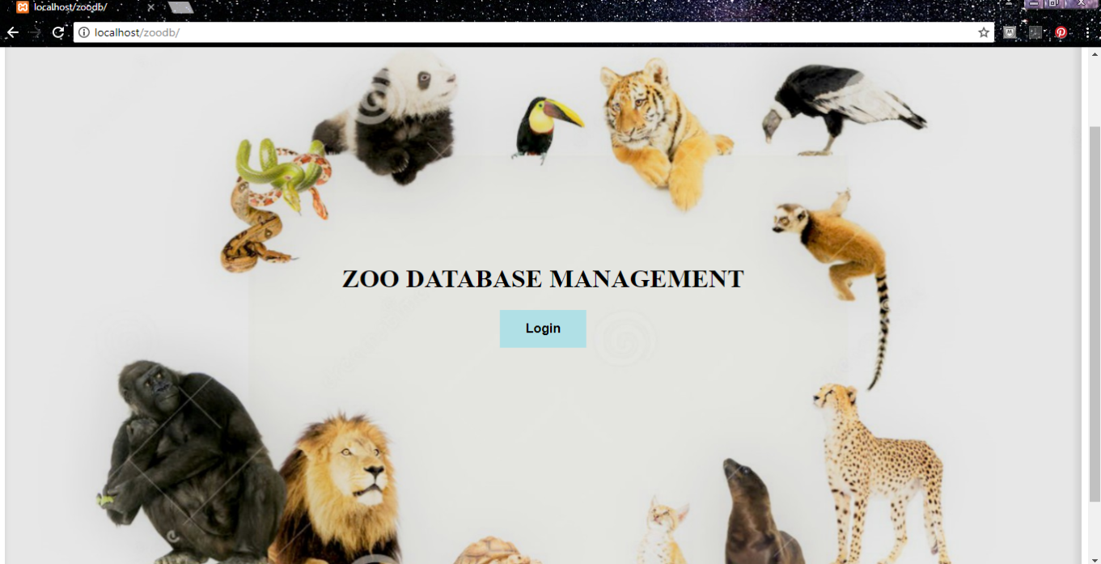

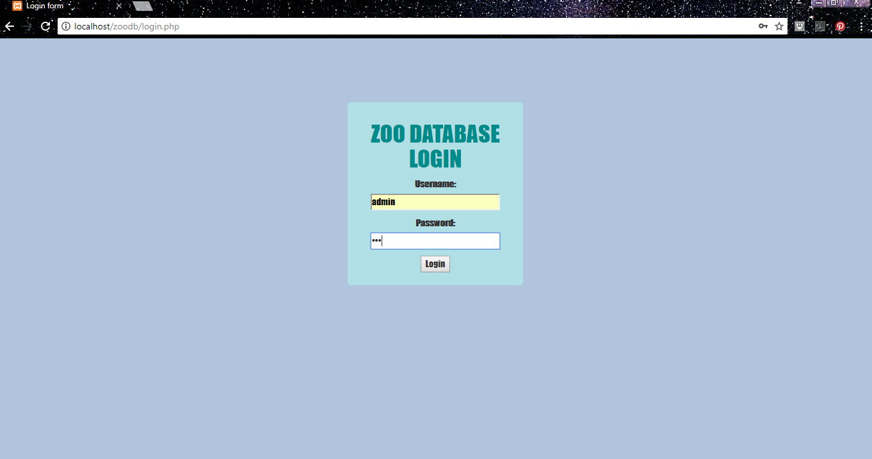

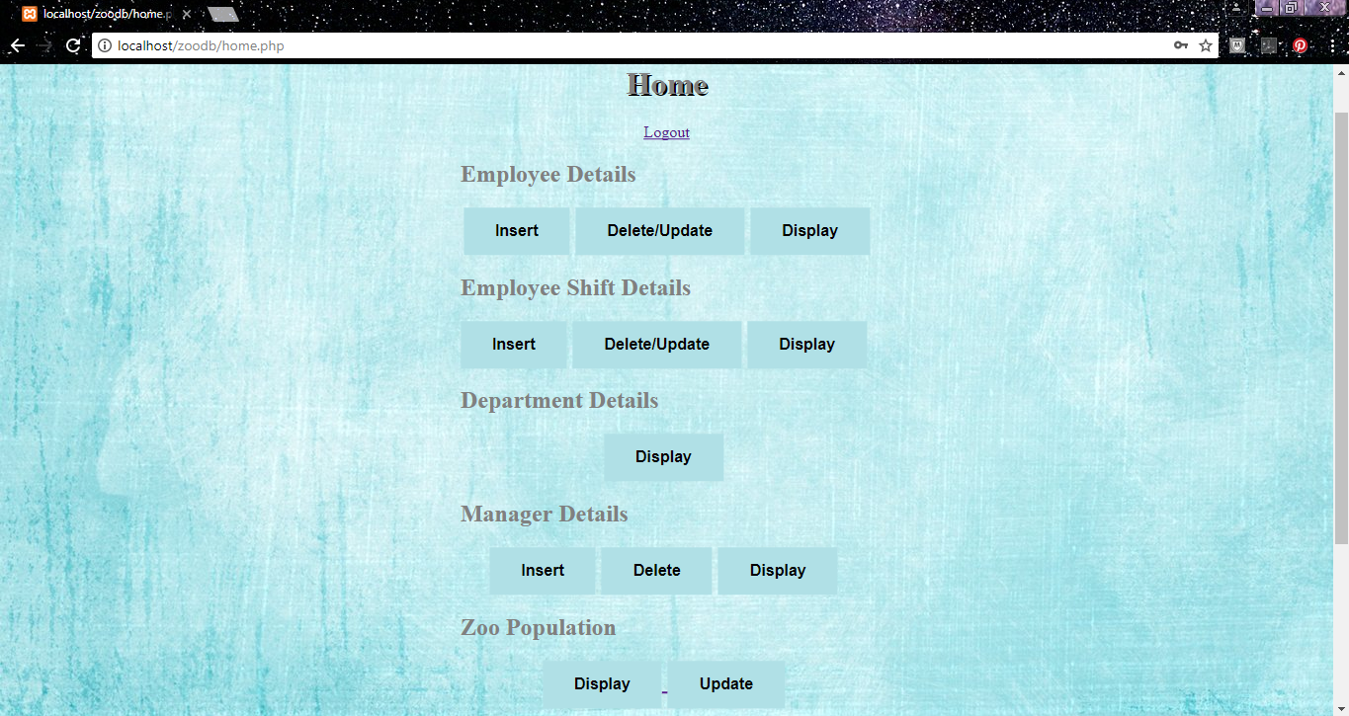

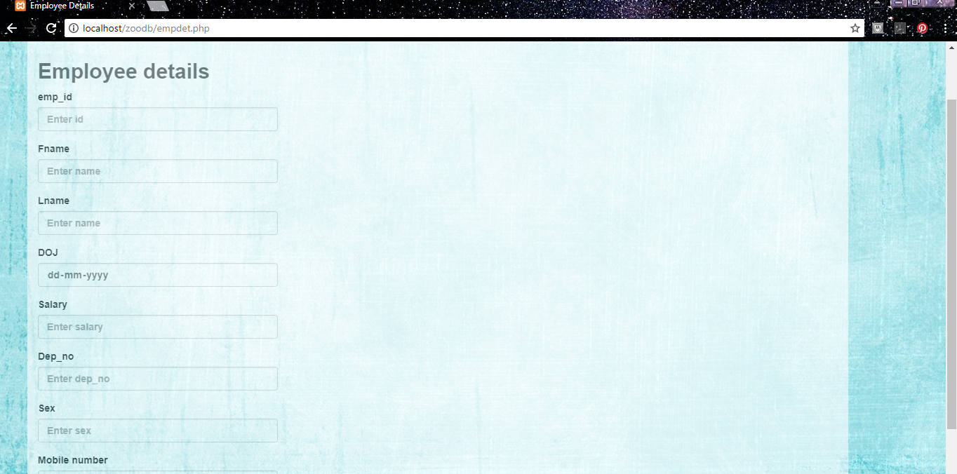

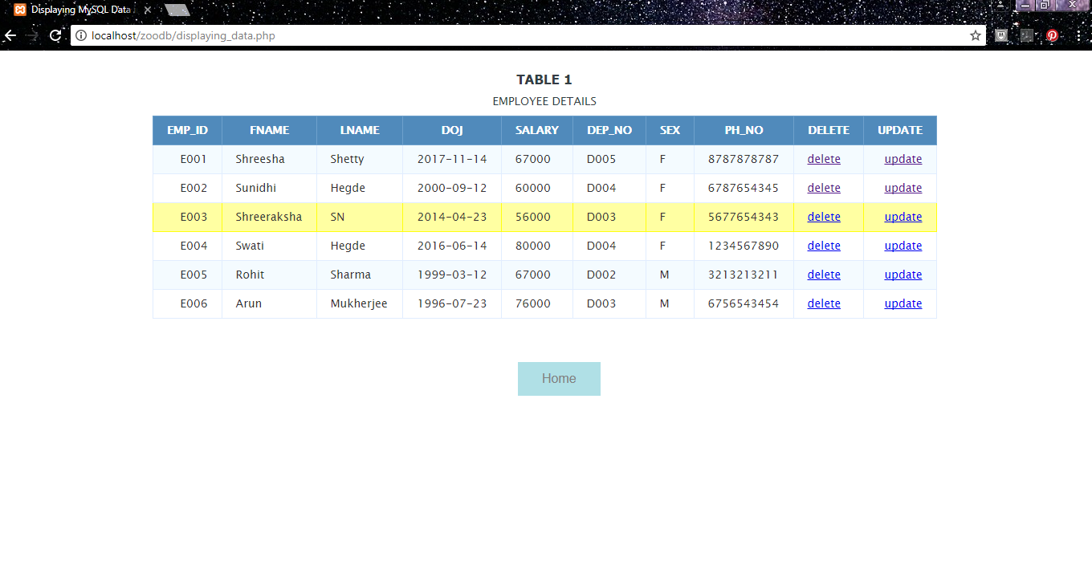

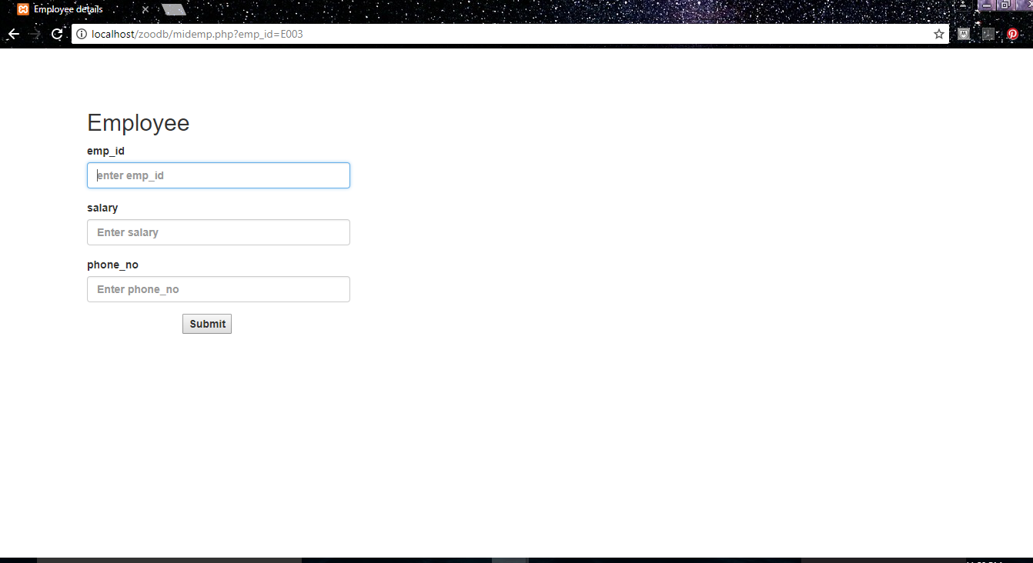

**CHAPTER 8**

**CONCLUSION AND FUTURE ENHANCEMENT**

The front-end tools used in this project are mainly HTML, CSS and PHP which can be further enhanced in their effectiveness to create a fully-fledged webpage which can be accessed by the administrators from any workstation/computer.

The database can also be expanded and developed further to add in more details regarding various facets of the institution like the total number of visitors per day, price of tickets and so on.

Zoo Database Management System is a project aimed at easing the burden of

recording important information about the zoo on paper. This venture provides a more secure and reliable means of data storage which is also very easy to access. The forms are very user friendly and make it easier for the administrators to interact with the database and retrieve information as and when required effortlessly. Thus, this project serves its purpose of being an effective data repository.

**CHAPTER 9**

**BIBLIOGRAPHY**

[1] [www.wikipedia.org](http://www.wikipedia.org)

[2] [www.w3schools.com](http://www.w3schools.com)

[3][www.stackoverflow.com](http://www.stackoverflow.com)